Stanley Wu

6/9/2023

Futures and Securities Latencies

In the futures file, I discovered that buying or selling a future can possibly affect response and return latencies of the exchange. I first looked at if the difference between buying and selling a future can affect the total latency of the transaction, and it seems as if selling a future requires more time than purchasing a future. I also created a new column that sums up the exchangeRspLatency and the exchangeRtnLatency to get the total latency between the exchange. I also did an analysis on the data, checking to see if the data that we need is normally distributed, and seems that it is from the boxplots shown, which indicate that there are certain outliers, but from the whiskers and the box, the data seems like it is relatively normal.

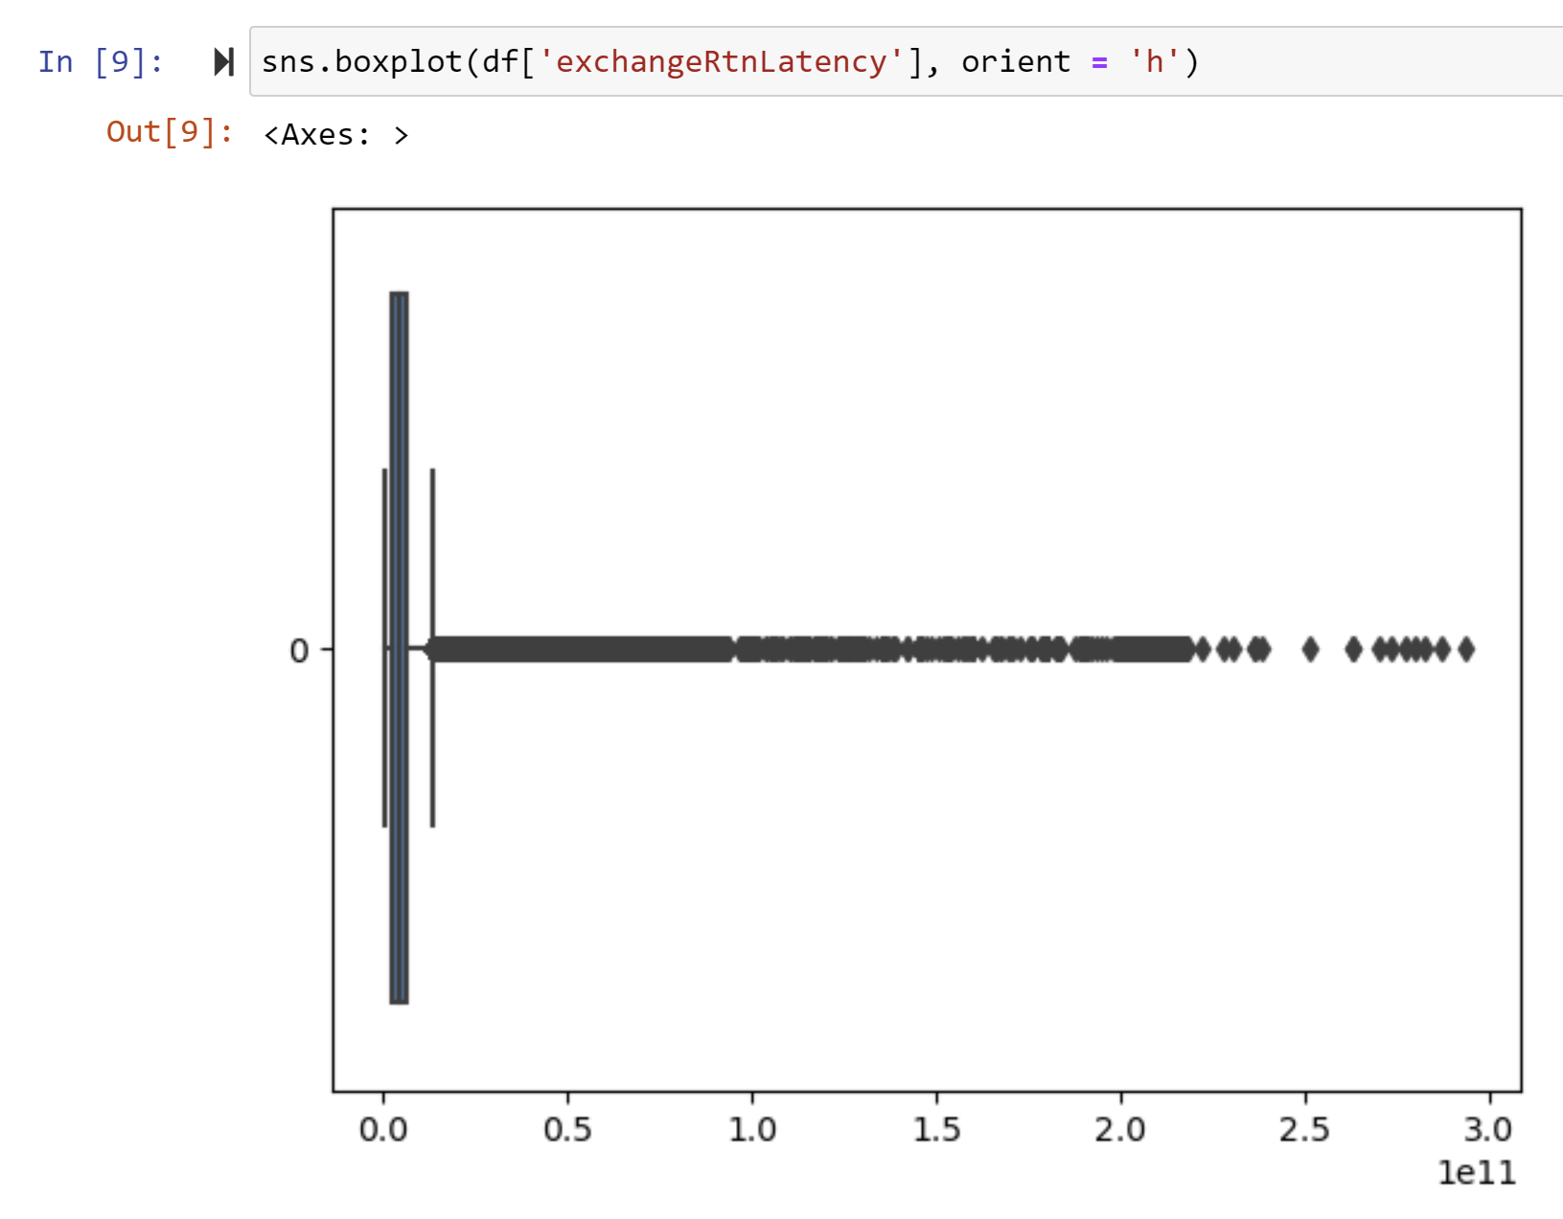 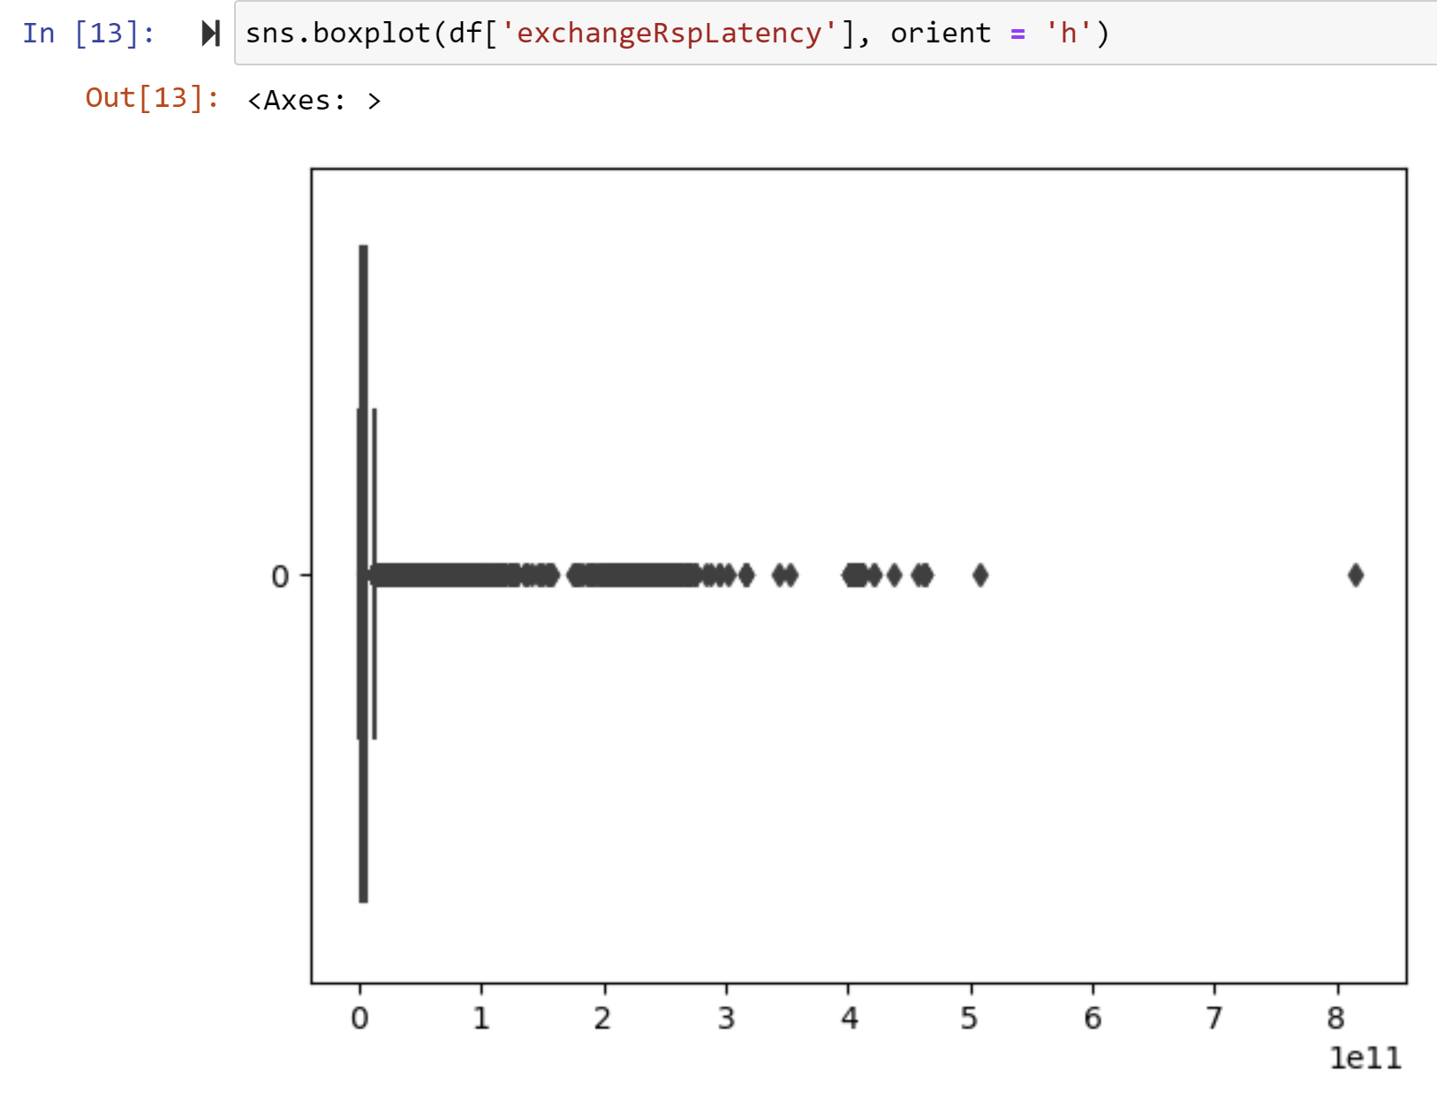

But when taking a look at the distribution of data through a histogram, it seems to be skewed more to the left, might have affect on the t-test if we were to compare values, from different entries, but since there is more than 100,000+ data entries, the t-test can still be performed as it is resilient against skewedness in larger data sizes.

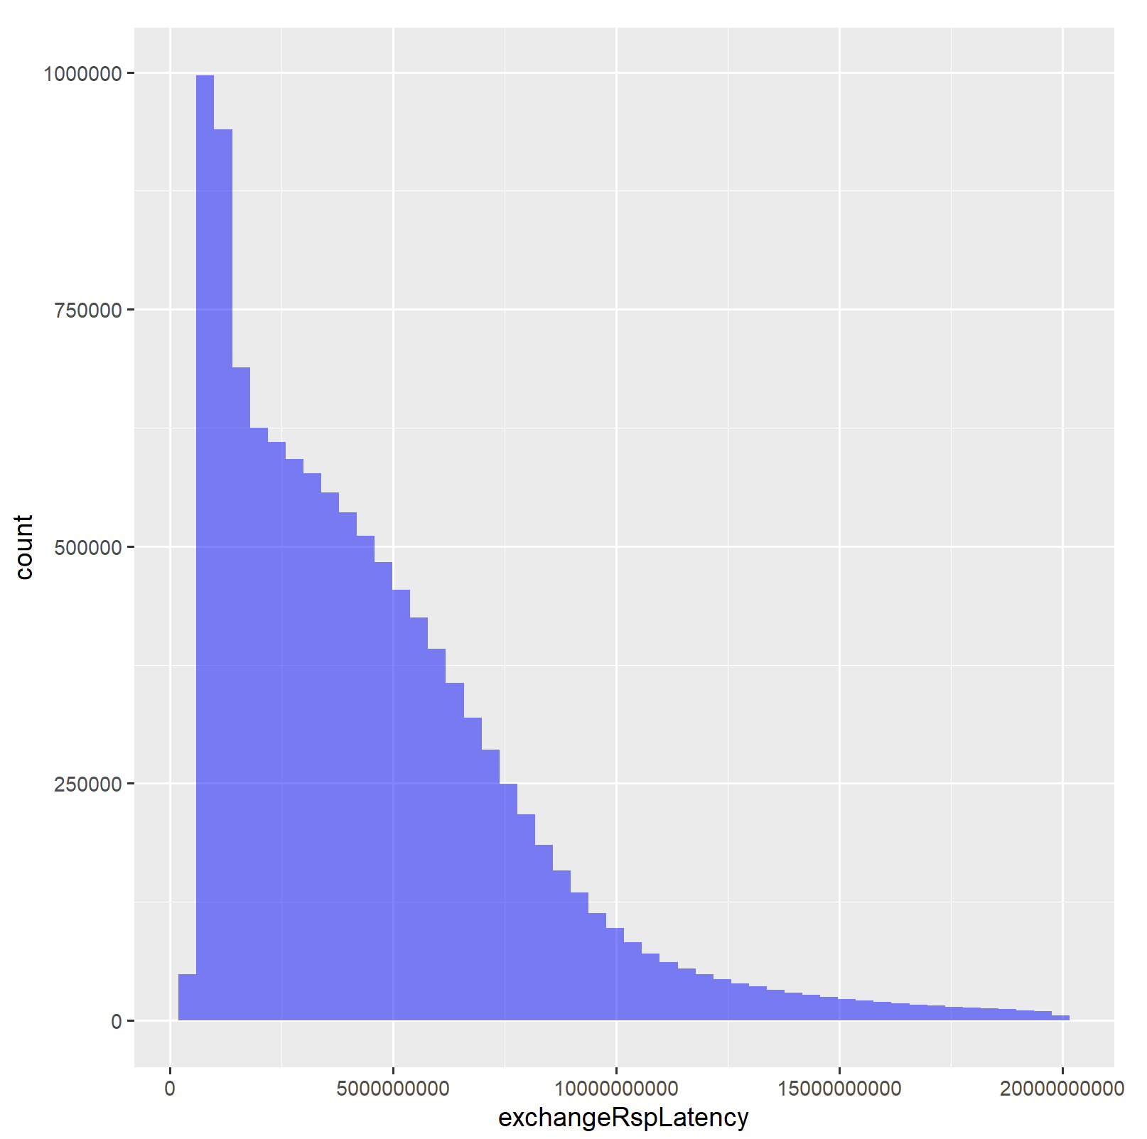 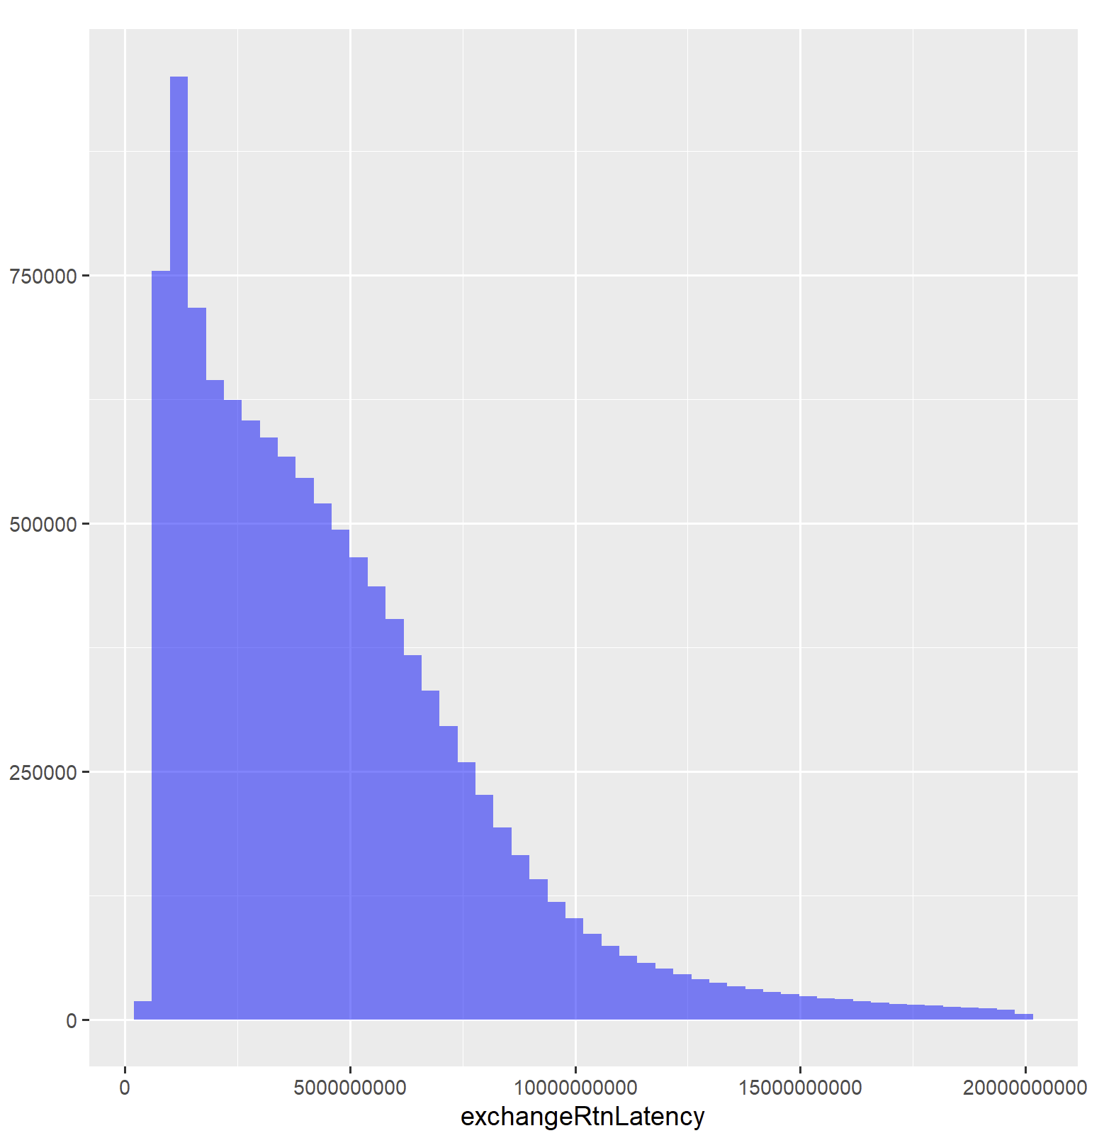

When performing the T-test on buying and selling from the exchange (since it has been proven that it is normally distributed), it clearly shows that there is a difference in the exchange latency for these actions, since the P-value of the function shows evidence against that they are equal, as the p-value is less than 0.1, which means that there is significant evidence against the null hypothesis, which would point that the latencies between buying and selling are equal. This means that a sell or buy order can affect the latency, with the sell order being slower to process than a buy order.

Another set of categorical variables that I compared were the combOffsetFlag, whether the offset flag was opened or closed. From my t-test, it seems like there is a significant difference between the offset flag being open or closed, as it being opened seemed as it produced higher return and response latencies. The p-value also backs this up since it is less than 0.1, which means significant evidence against the null hypothesis. 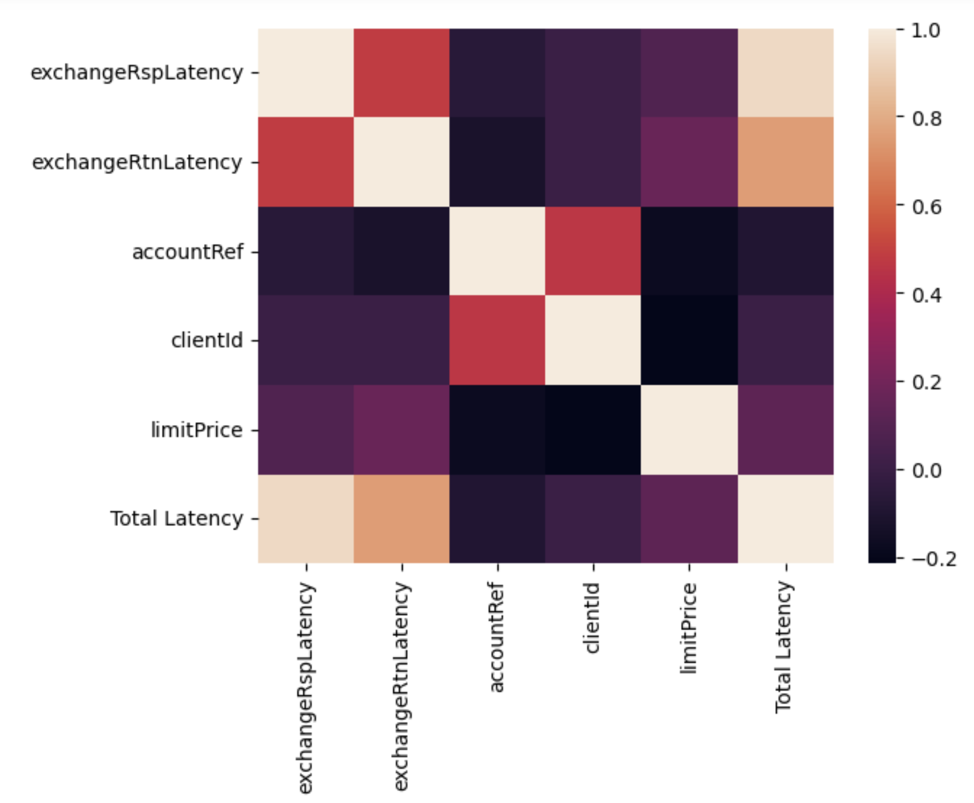

The heat map of the charts shows the numerical values and their correlations towards the exchange response and return latencies. It seems that the limit price and client ID has some effect on the exchange’s return and response latencies.

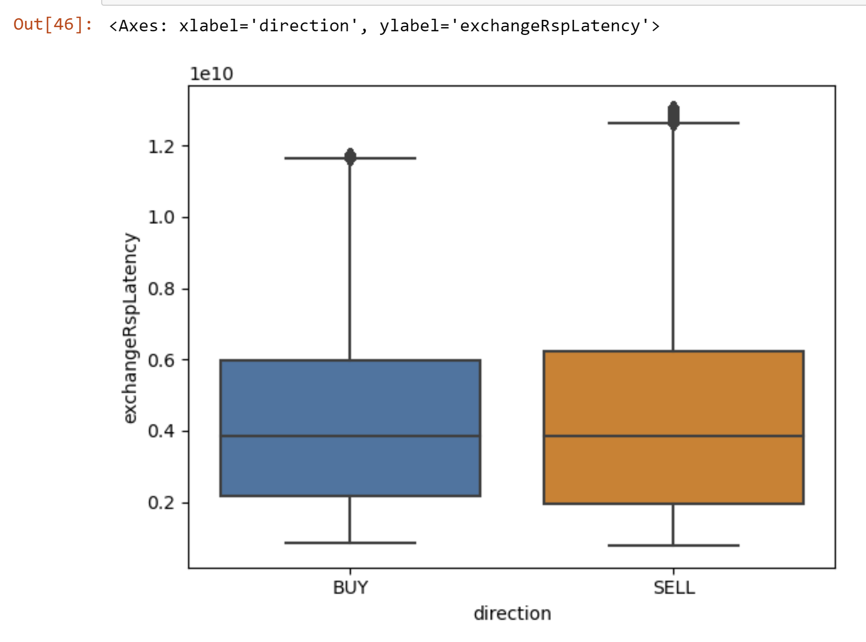 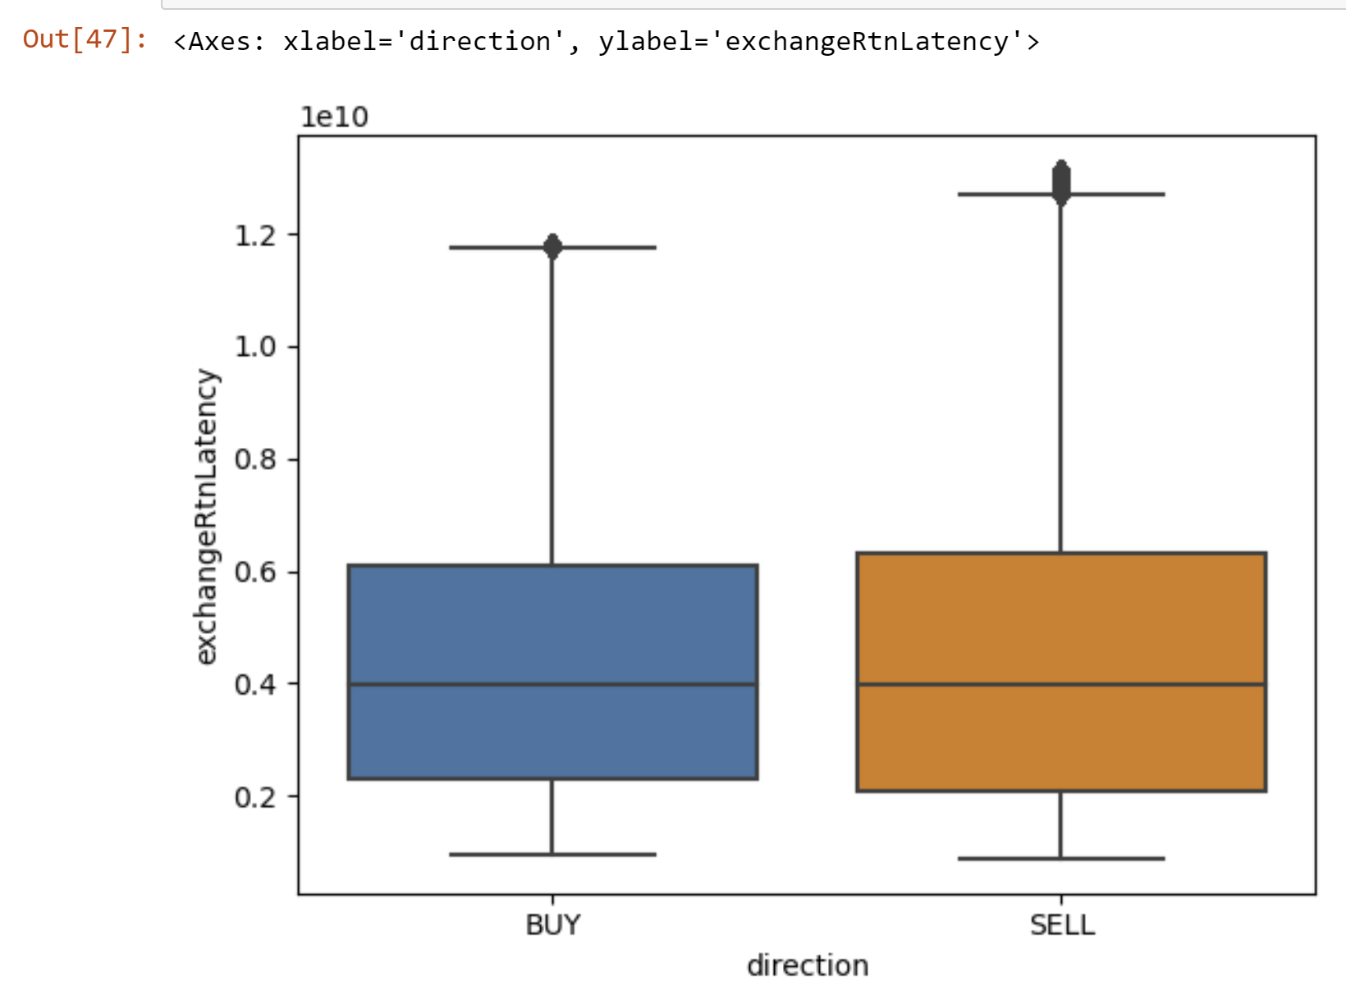

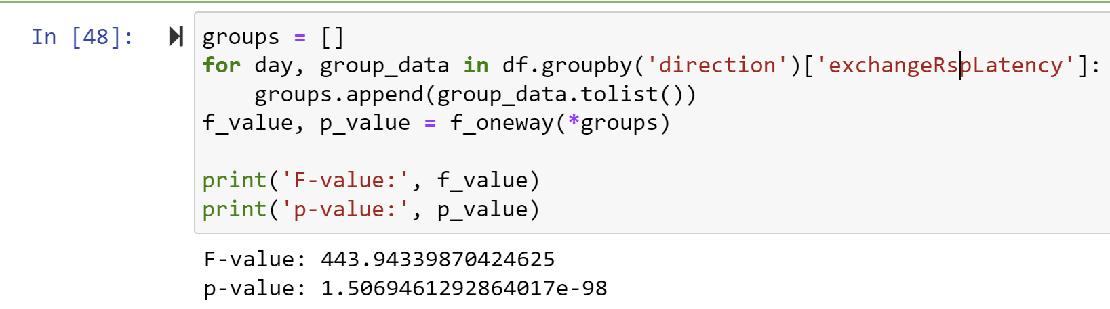 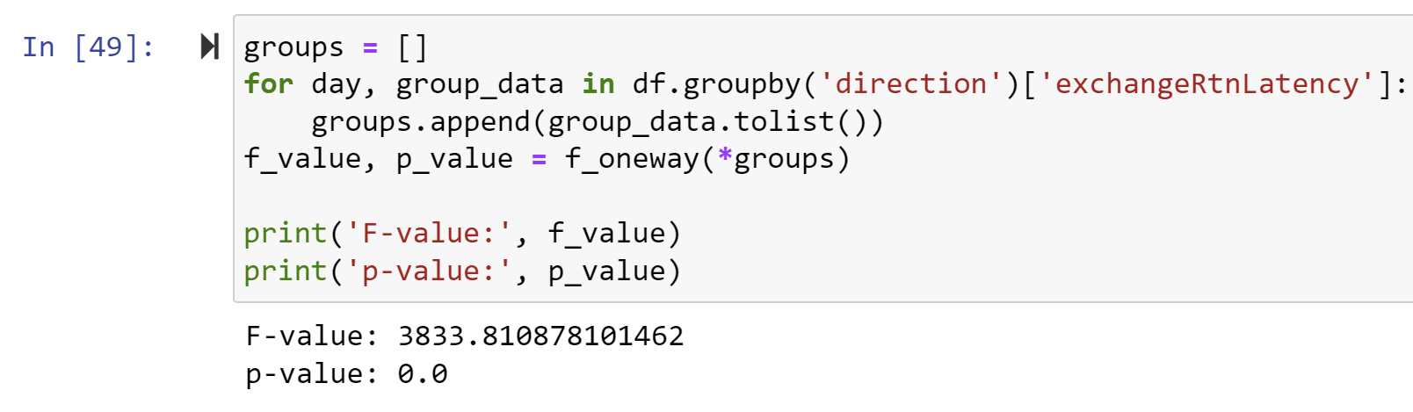

The box and whisker plots show that there is a idfference in terms of buying and selling securities, as there seems to be a longer response time for selling versus buying, and to perform a t-test on this, shows that the p-value is less than 0.01 on both of these latencies, which means that the difference between buying and selling does have an effect on both latencies.

Another test I decided to perform this on was the combOffsetFlag, the box and whisker plot shows that if the combOffsetFlag is open, the latency from both return and response is faster, and this is further confirmed from the p-value in the t-test, since we know both

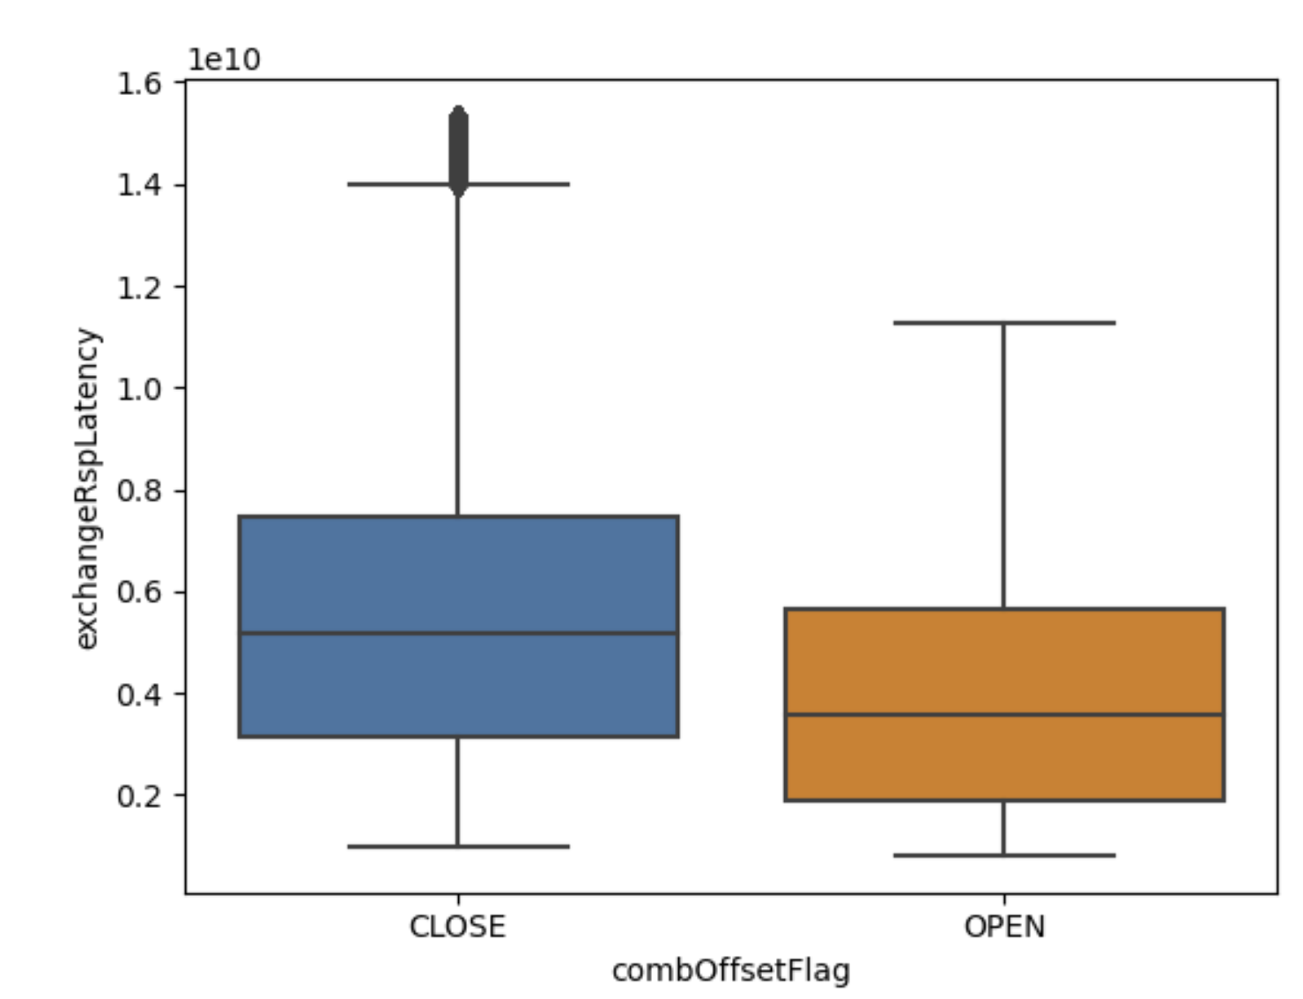 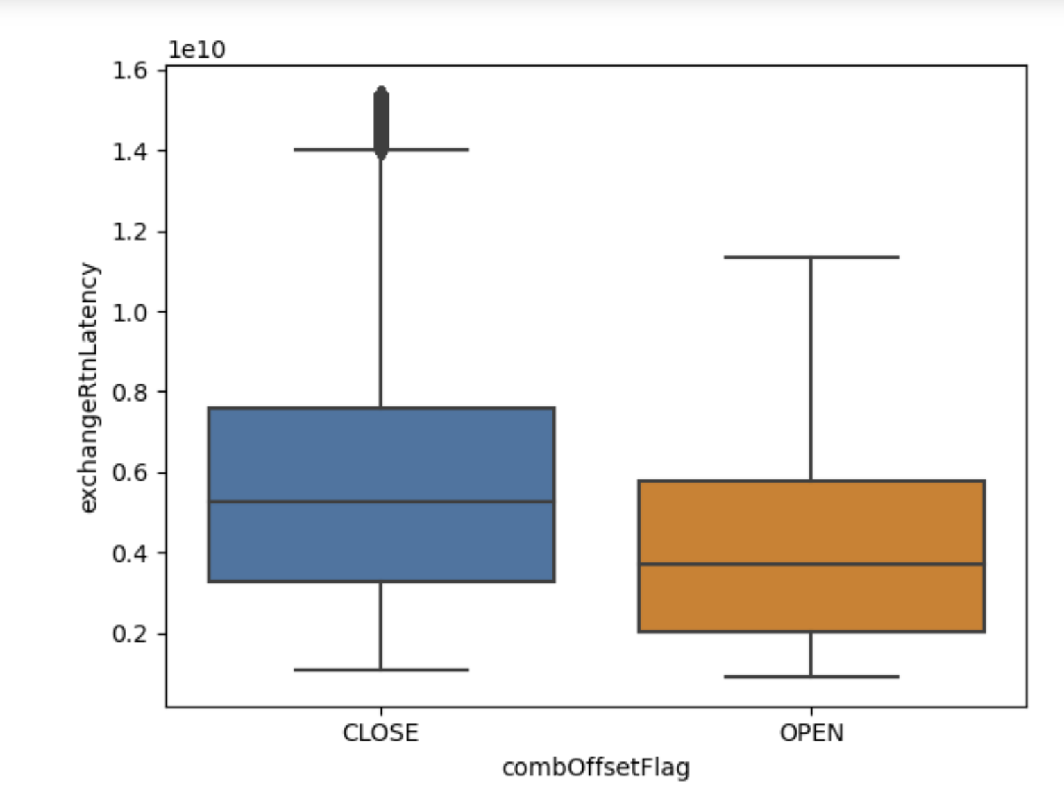

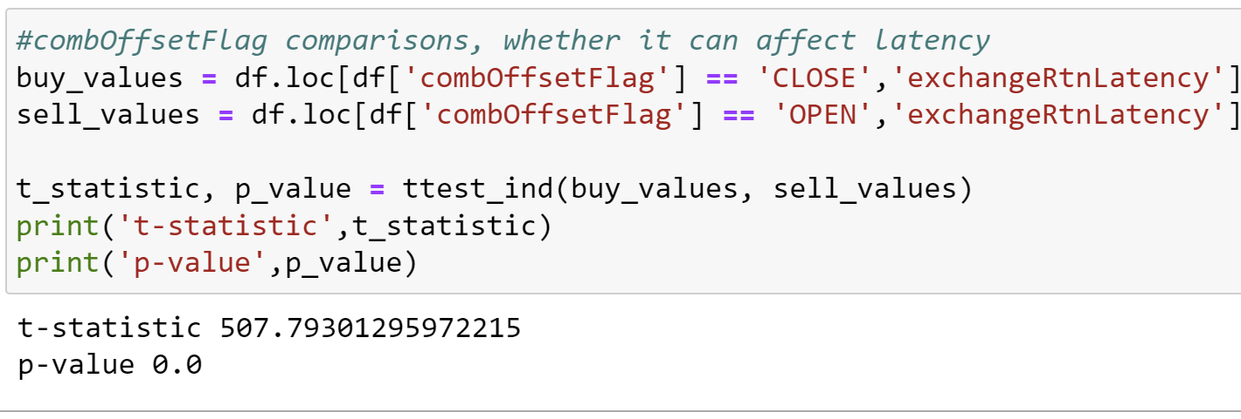

There also appears to be a difference in instruments used that could also affect the rate as different instrument types such as the T2, TF, and TS instrument recorded lower latency rates than those of the IC, IF, IH and other I labeled instruments. But out of all of them, the slowest devices used to perform transactions was the MO instruments, which performed the slowest by a mile in terms of Response Latency. The exchange return latency also tells a similar story, as the T instruments seem the fastest, the I instrument come in second, and the M machines are the slowest in terms of latency time. It also seems that the IM and IO are the slowest instruments in the I line of instruments, as they have response and return rates of around 6e+9 and 8e+9 respectively. This shows that if you want a lower latency rate, you need to use a T instrument to conduct your buying and selling of futures to ensure the quickest response rate.

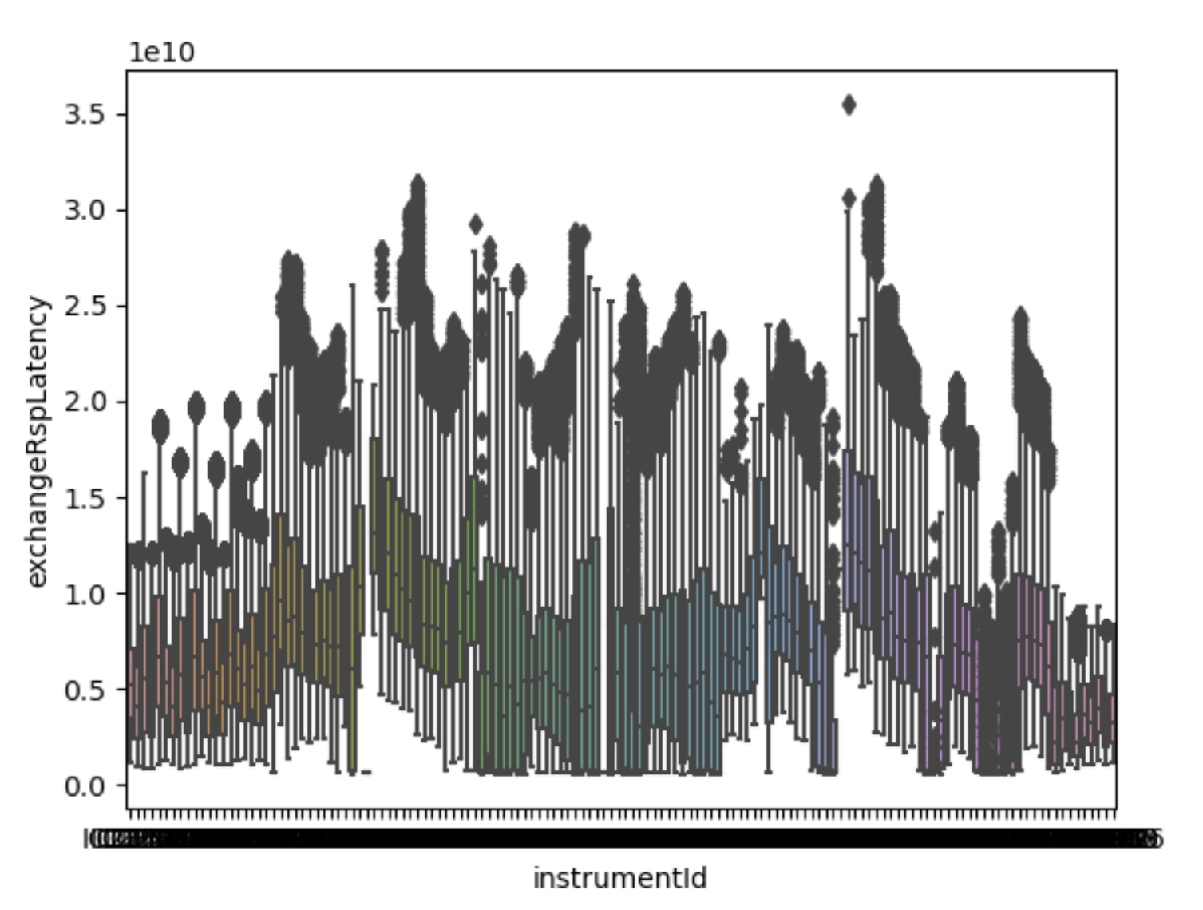 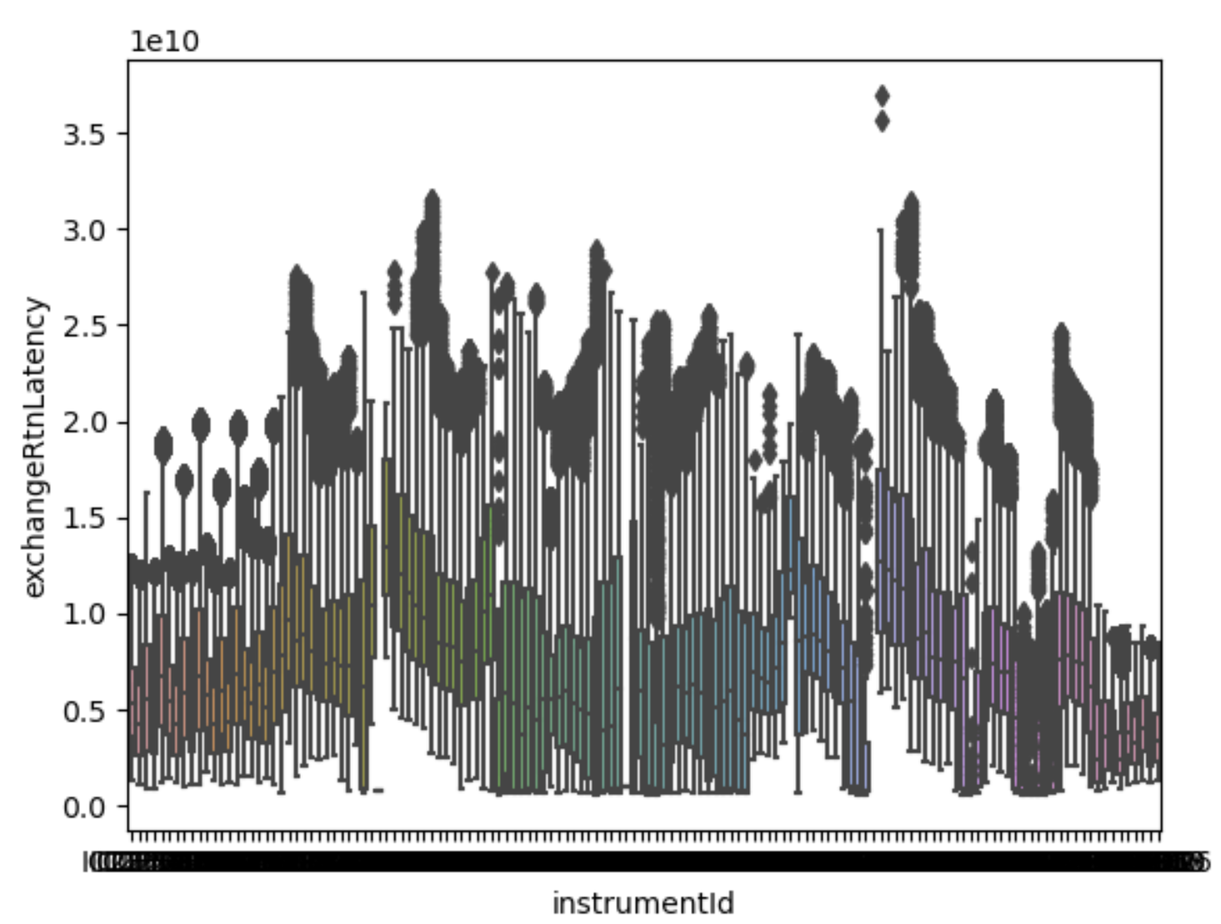

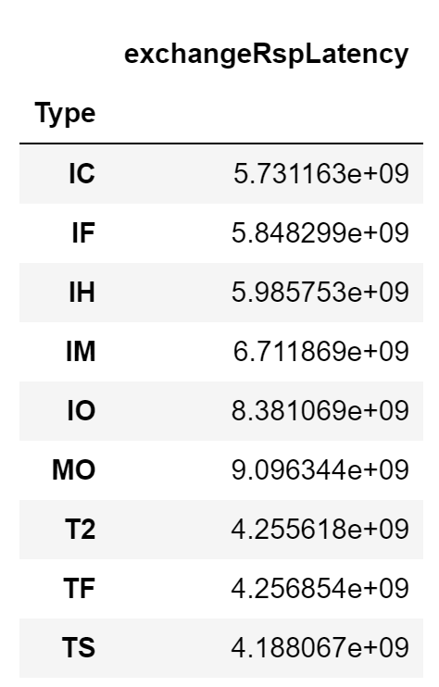 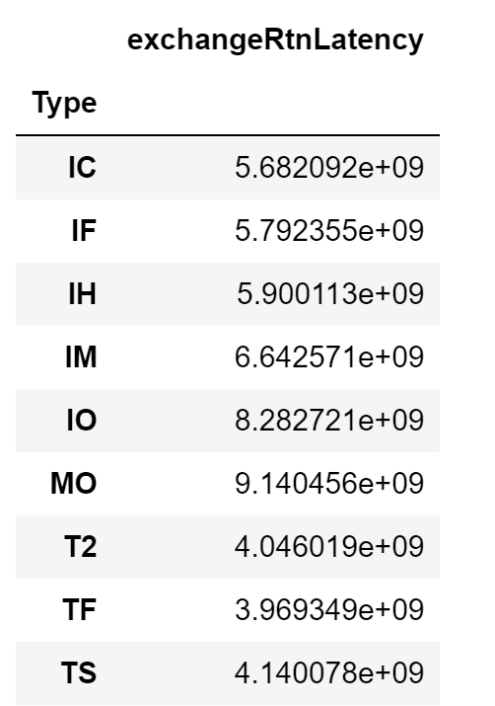

There is also a difference between the latency time from the IP exchange servers, but since there are multiple categorical nominal variables, it would be hard to perform a t-test for all of them, so I decided to perform a T-test for only the values with the largest difference, which were the IP addresses ending in 51, and 59, which showed a significant difference in the latencies as the P-value was smaller than 0.1, which meant that there was evidence against the null hypothesis. It showed that the IP address of the server in which the order is sent to might add latencies to the order as it might take longer for the order to travel to its destination. 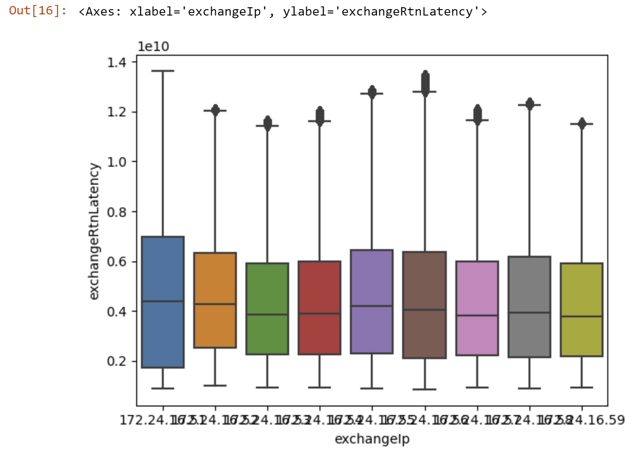 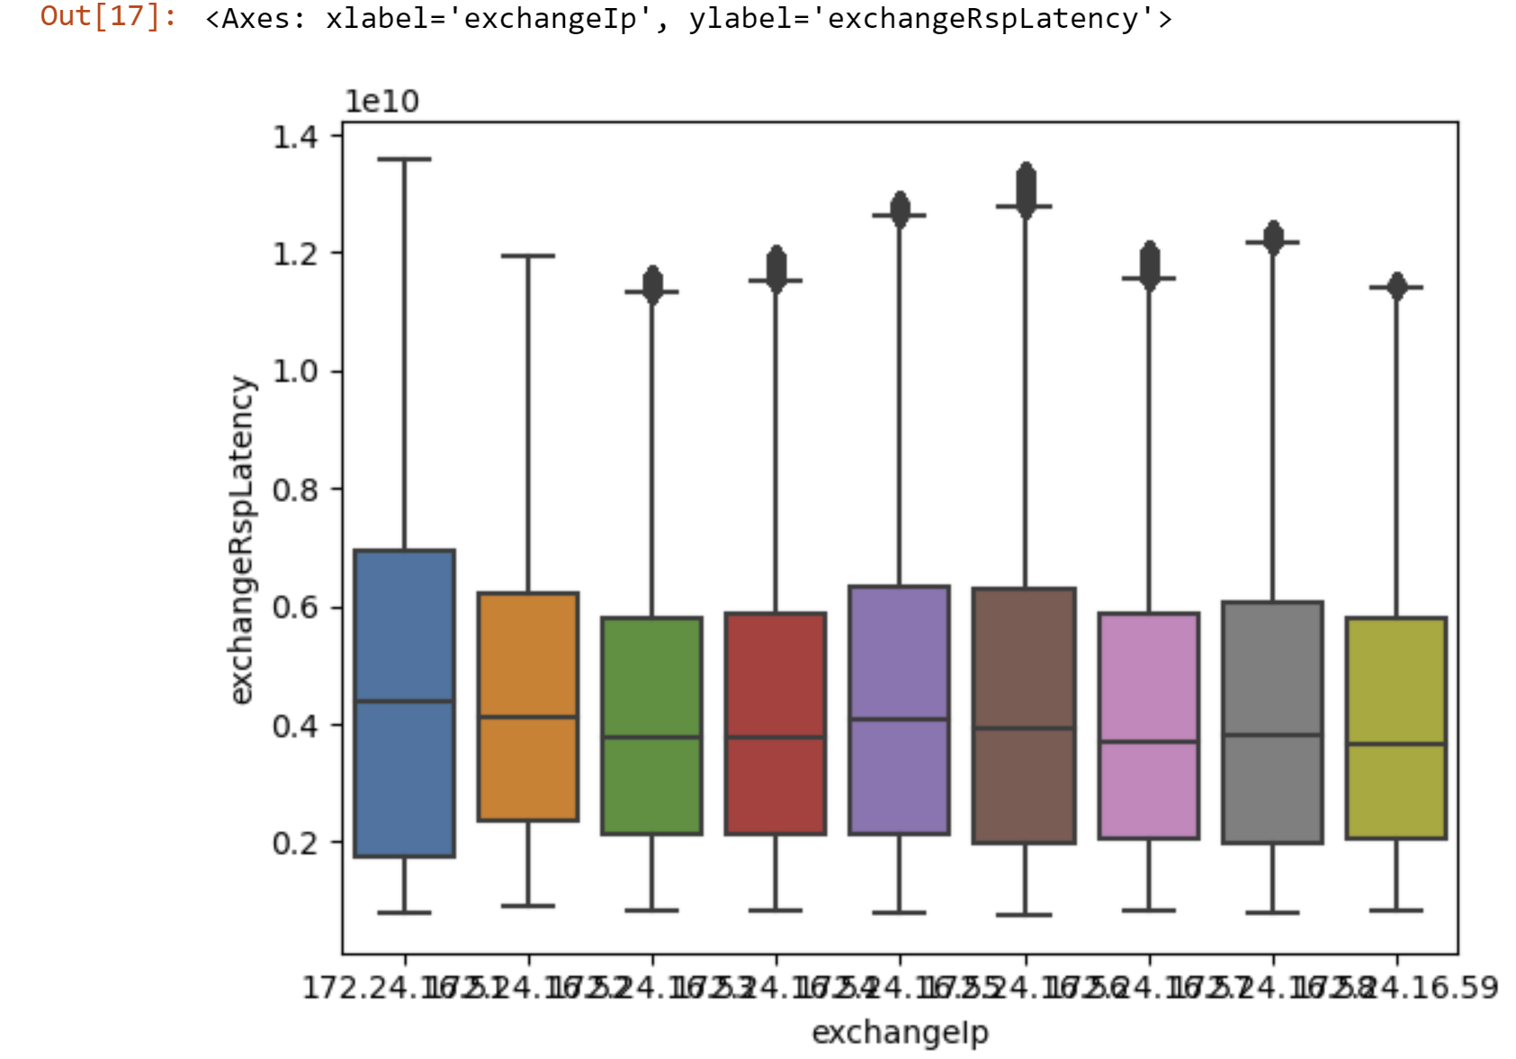

The IP values were shortened since there were only 9 values.

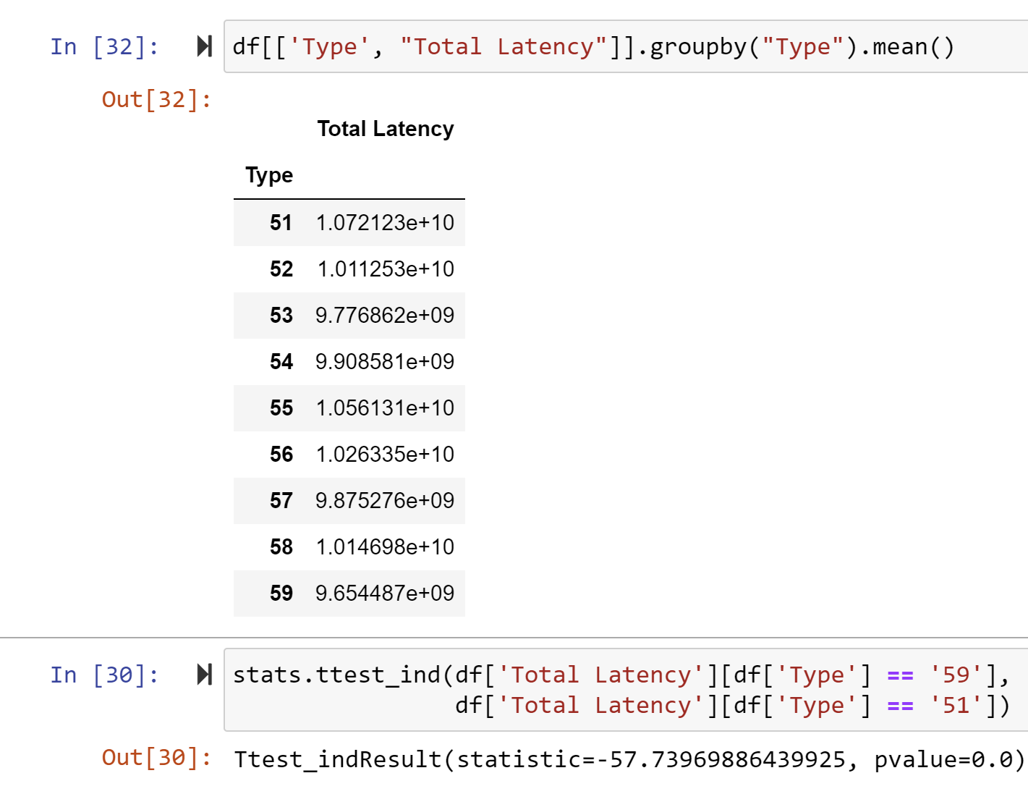

Another value that I decided to look at was the time of day, to see if sending an order during a certain time of day, and the order volume would also affect the latency time of the transaction. I performed an AVONA test, since there were multiple categorical variables for dates, and this showed that the certain date would also have an effect on the latencies, as the p-value is less than 0.1, showing significant evidence against the null hypothesis.

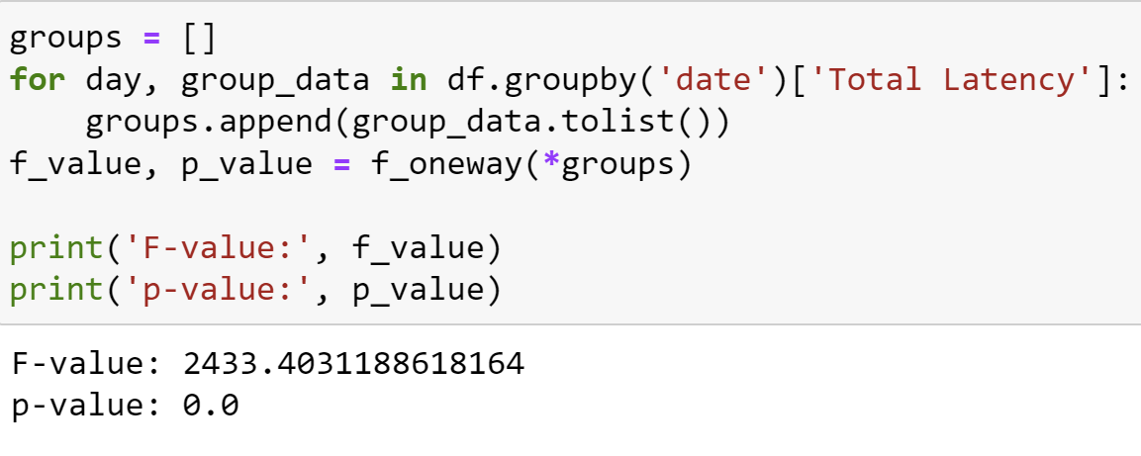

I then looked more into the certain time of day, and that a latency might occur during some time of day due to some reason. I used a scatter plot to more accurately see the results, as there were was too many specific times to perform a t-test on the data. The plot below shows that there isn’t really a clear relationship between the dates and the total latencies, and this was a similar result that I achieved when compareing dates with exchangeRspLatency and exchangeRtnLatency variables. The data also seems normally distributed between all the dates, and there doesn’t seem to be a certain day in which trades have faster or lower latencies.

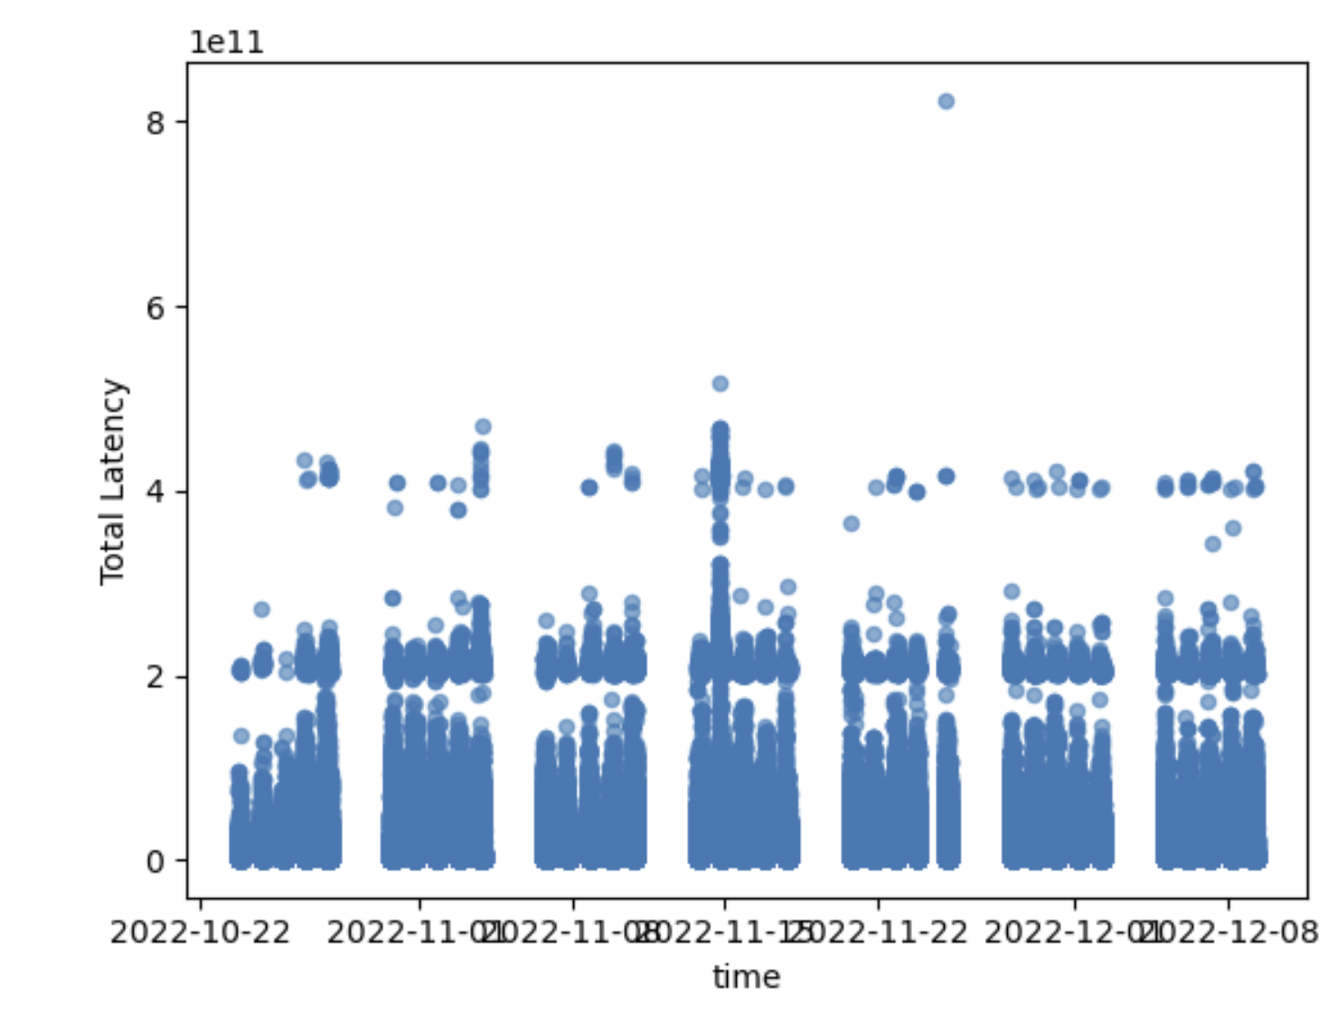

Another comparison that I performed was whether there was any influence in latencies in the time of day that trades. And one observation that I’ve noticed is there is a higher volume of trades occurring at around the 0.5 time of day, which is around noon. This is evident as there is also a higher number of exchanges being performed at that time, and I believe the volume of trading during that time of day can also affect the latencies of trades. Although it seems that the values seemed evenly distributed, if you inspect the cluster of data around 0.4, There seems to be a higher volume of data there, and it shows that this can also result in a higher latency.

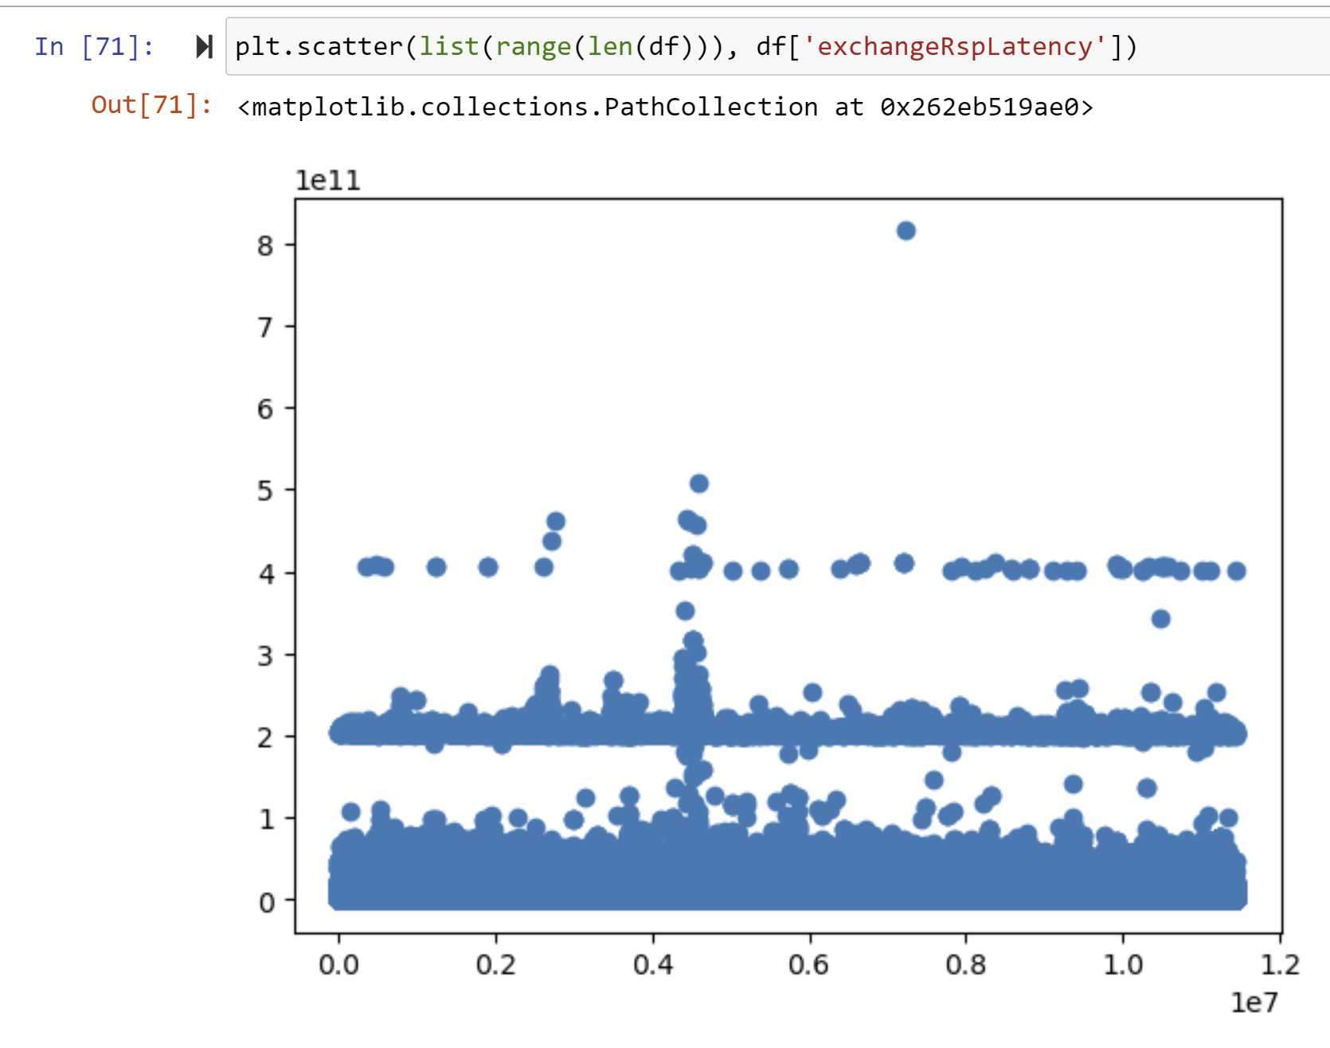 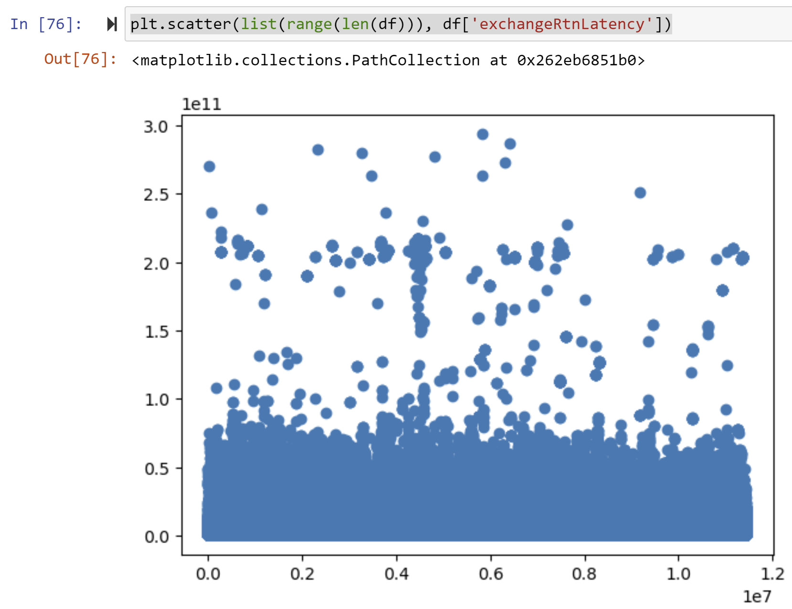

I also took a look at the counterIps by further comparing them with box and whisker plots, and performing t-tests to find p-values that show if they affect the latencies. (perform the t-test in linear regression)

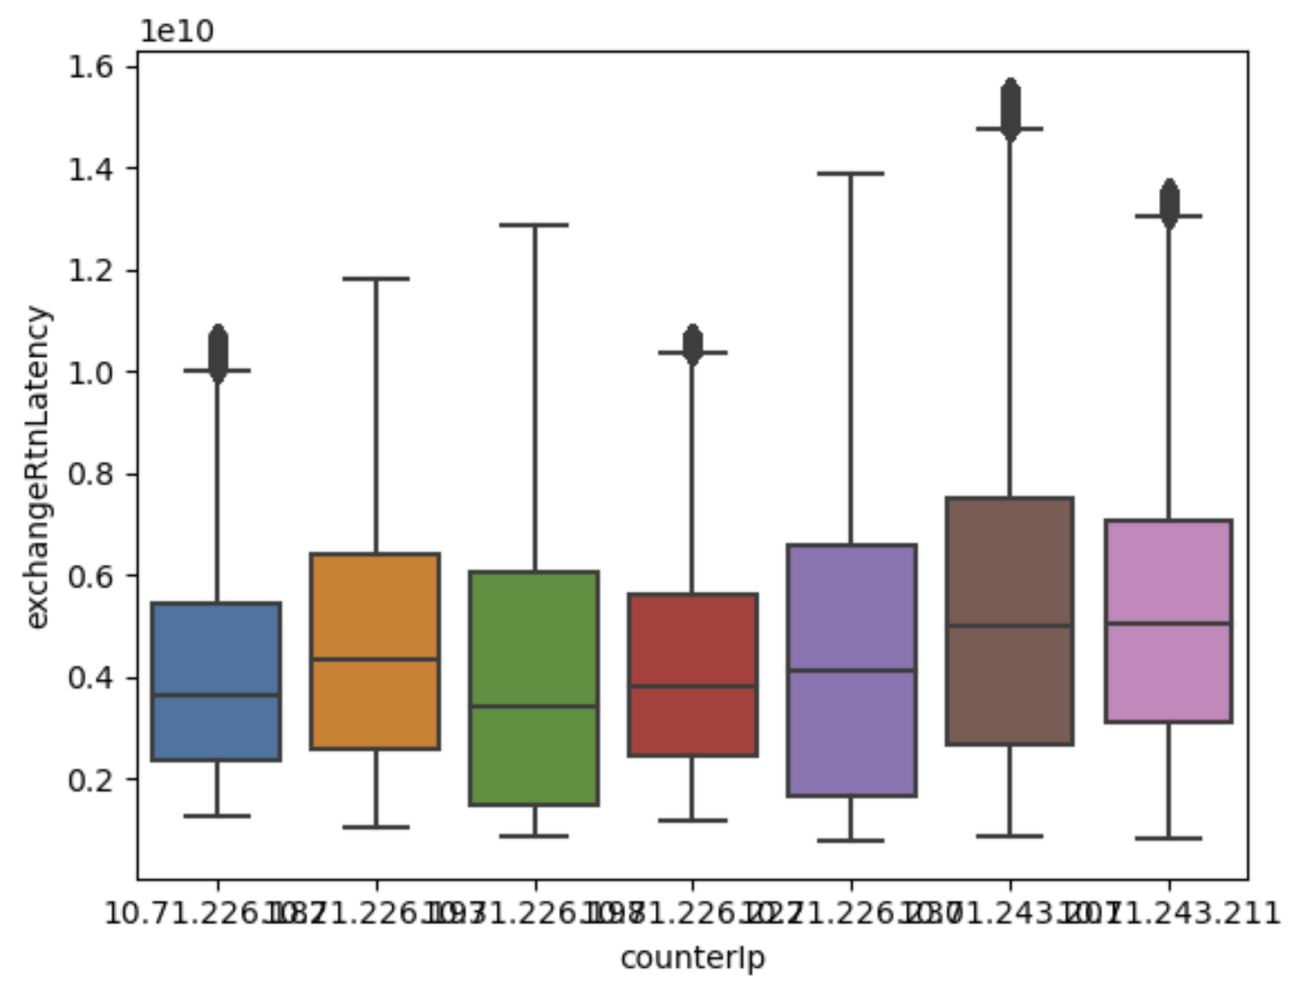 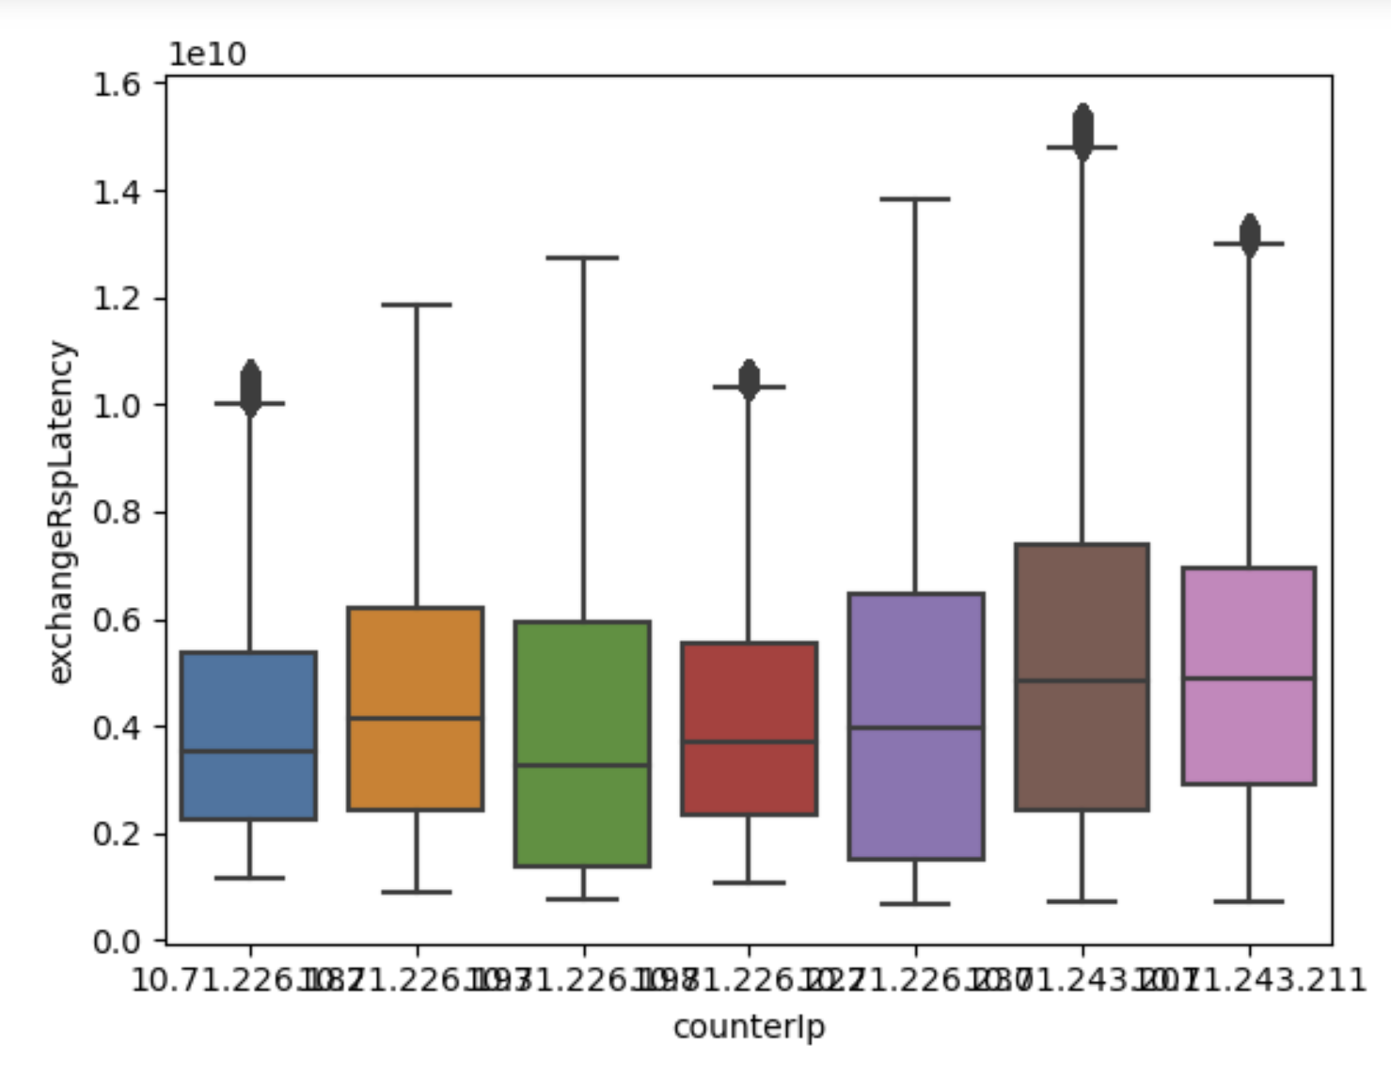

Another factor I looked at was clientIP, when doing the box and whisker plot, I noticed that there was very high volume, and that it might not have been normally distributed for every single IP, which can be a potential error in analysis from collecting data. 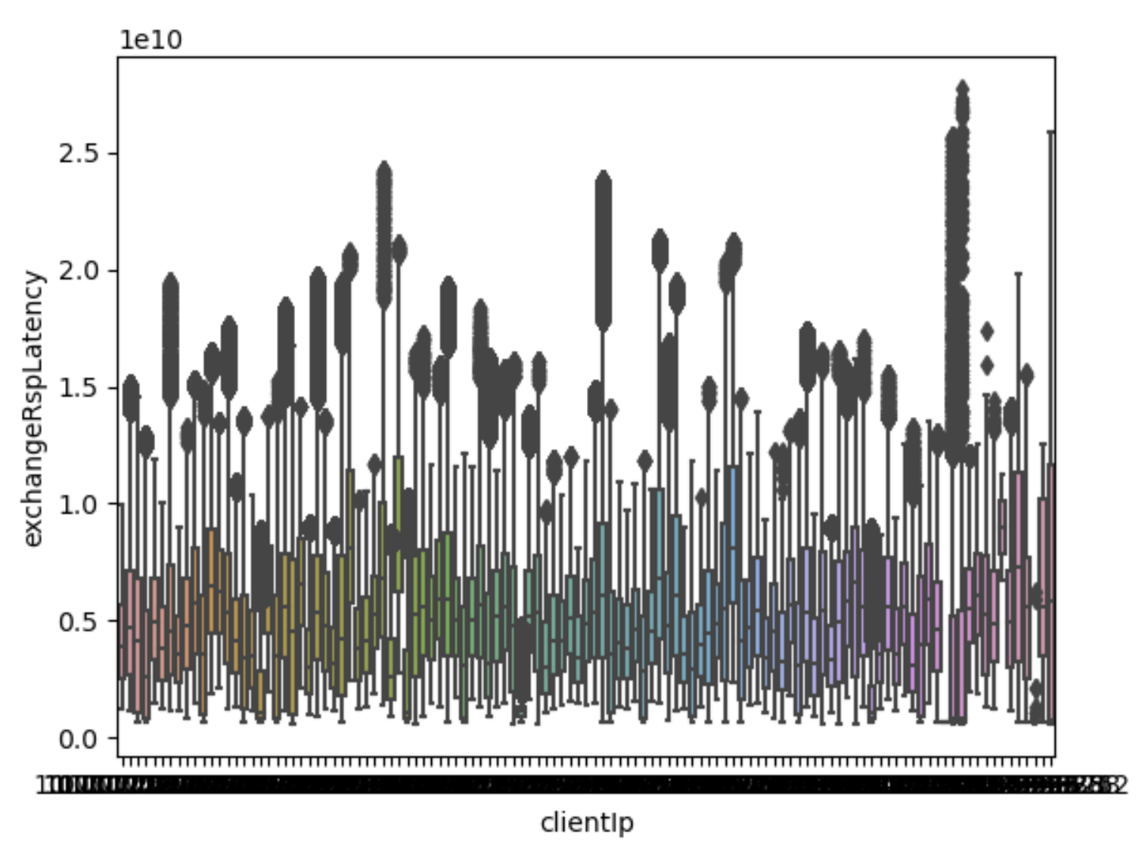 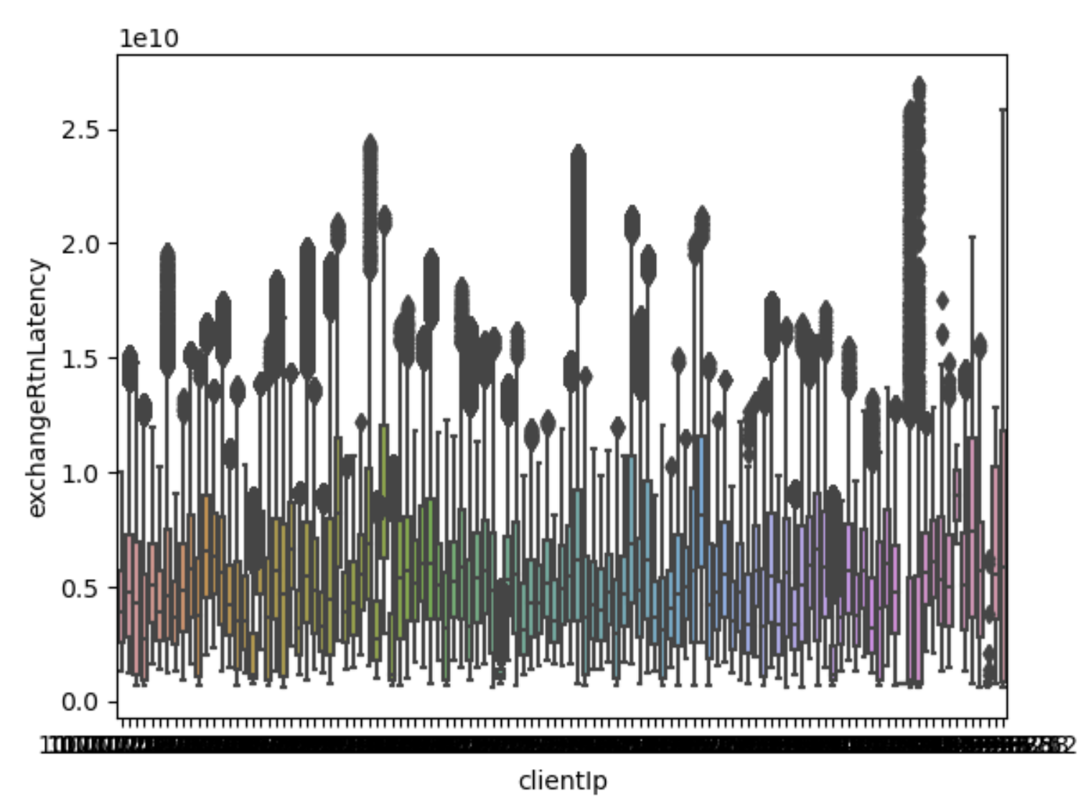

For the securities exchange, doing a basic correlation test of all the variables with each other didn’t reveal much. I first deleted the columns with only one unique answer in the column, such as submittingPbuid, applId, tgwInsertRspLength, counterIp, and counterInsertReqLength. I then plotted histograms for all the values, and checked if they were normal distribution. Looking at the distribution charts below, the counterLatencies are both left skewed, so we can still use the t-test on these groups. The InsertLinkLatency and tgwLatencies show more of a twin-peaked distribution, which means that for tests, we would need to use a k-clustering system to identify which variables can affect the latency there.

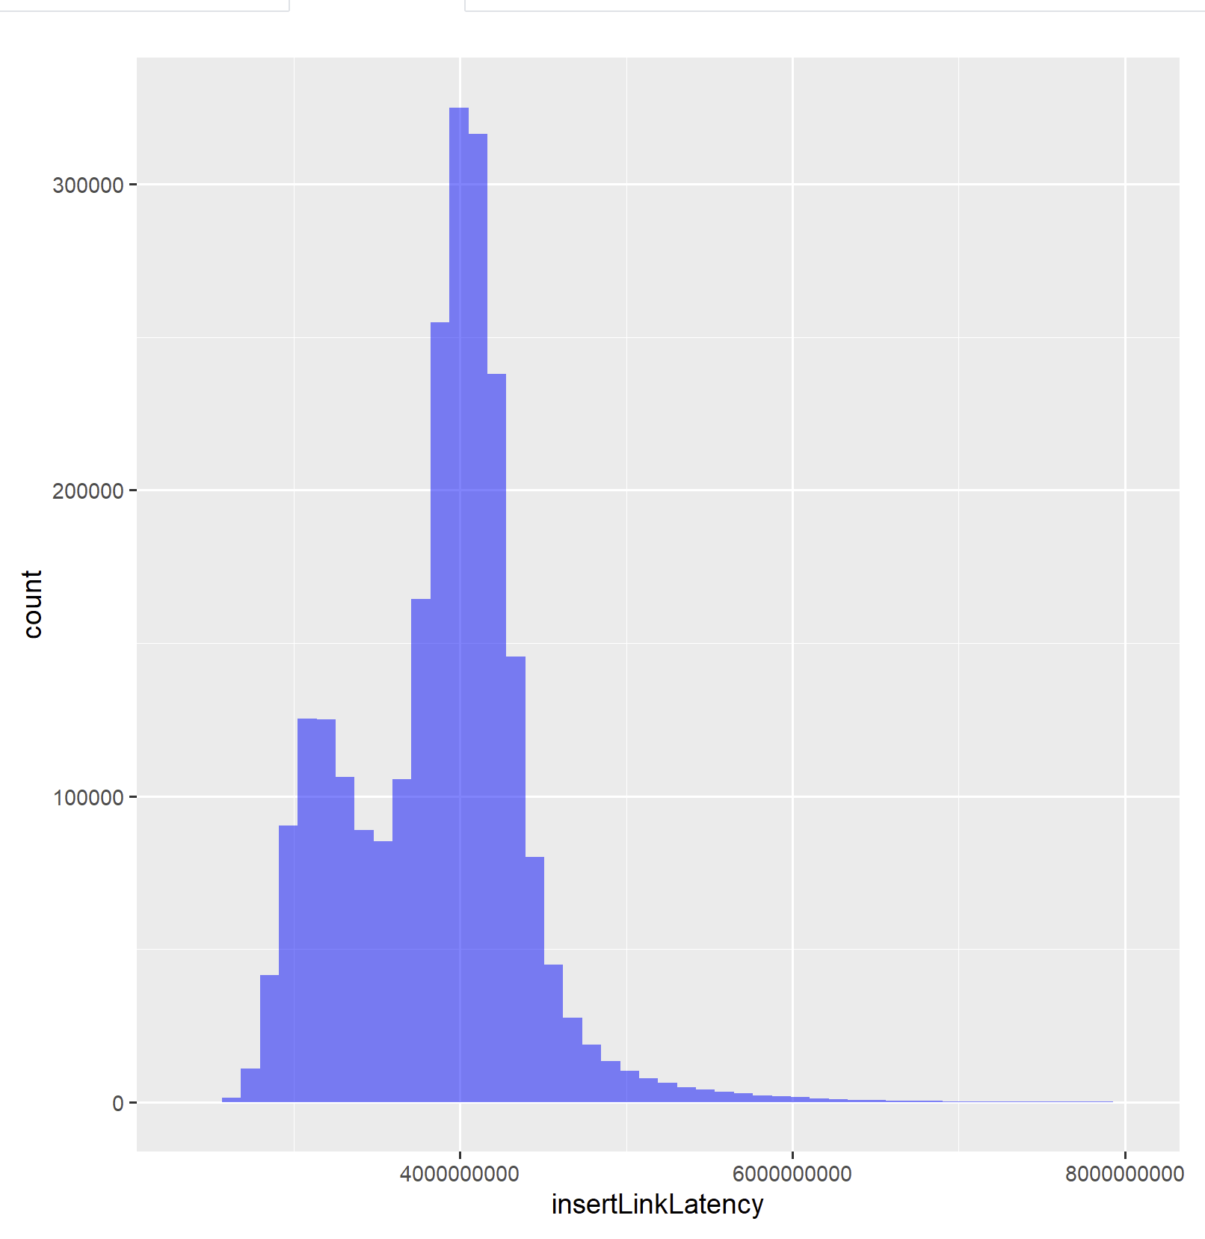 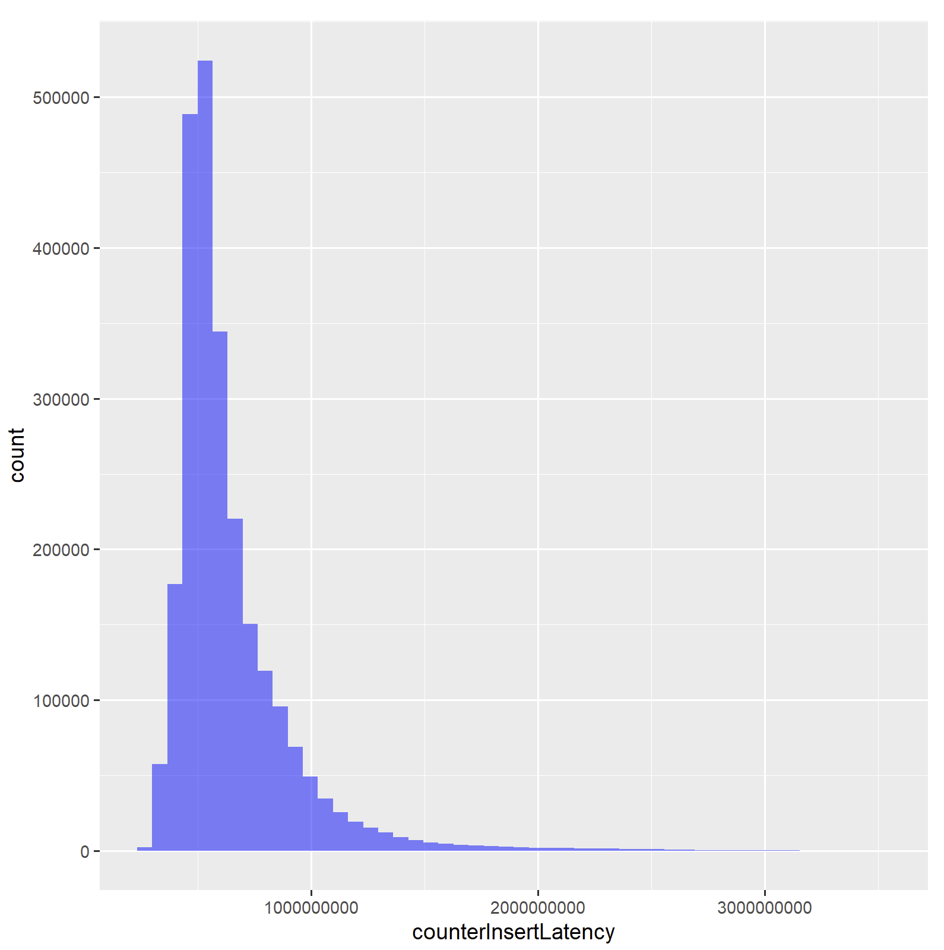

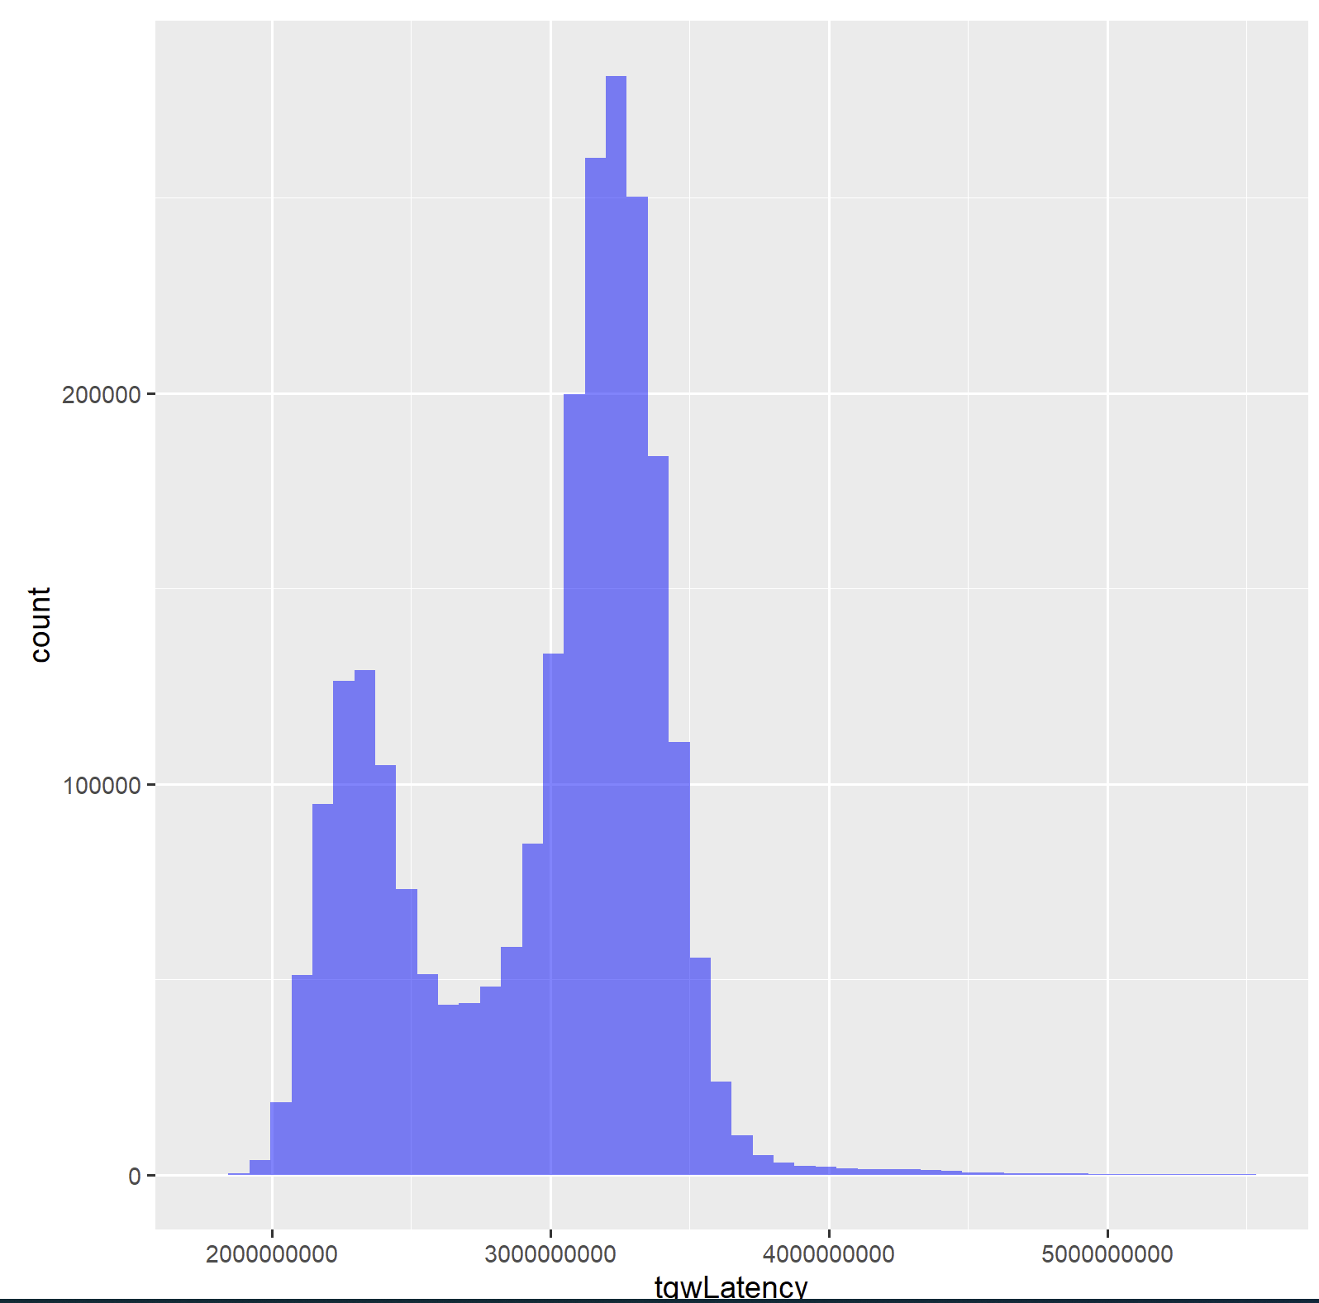 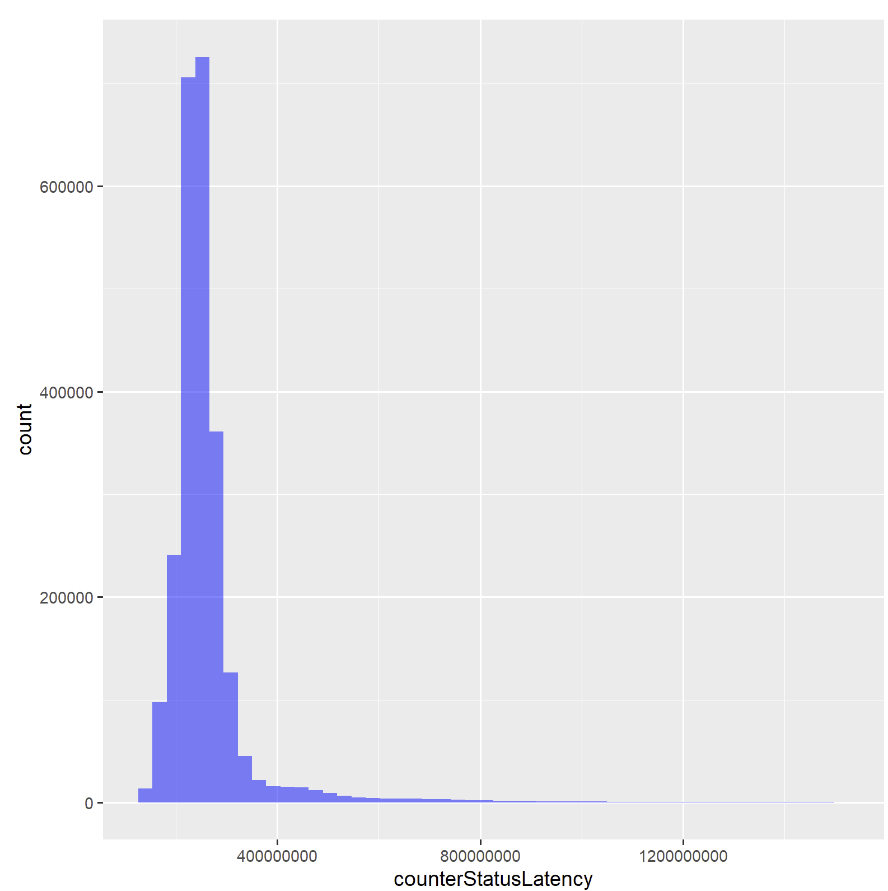

First deleted some extra columns that didn’t have value such as execType, orderStatus.

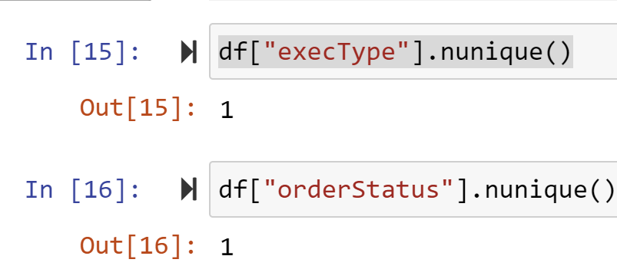

Then I looked at the time versus the latencies for each category, and I found that there seemed to be more volume of trades in the morning, and that has also led to higher latencies in insert and counterInsert latencies.

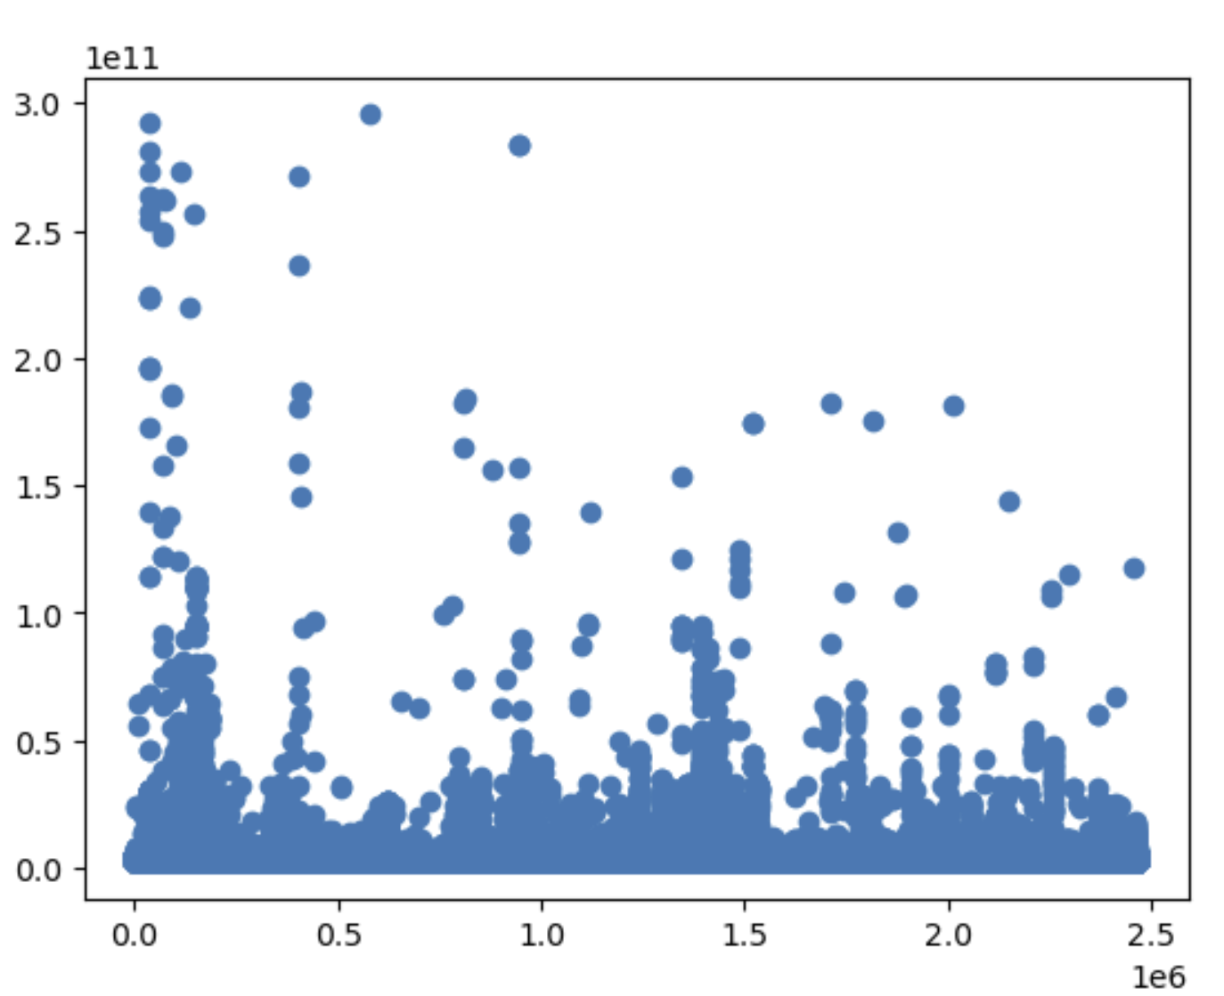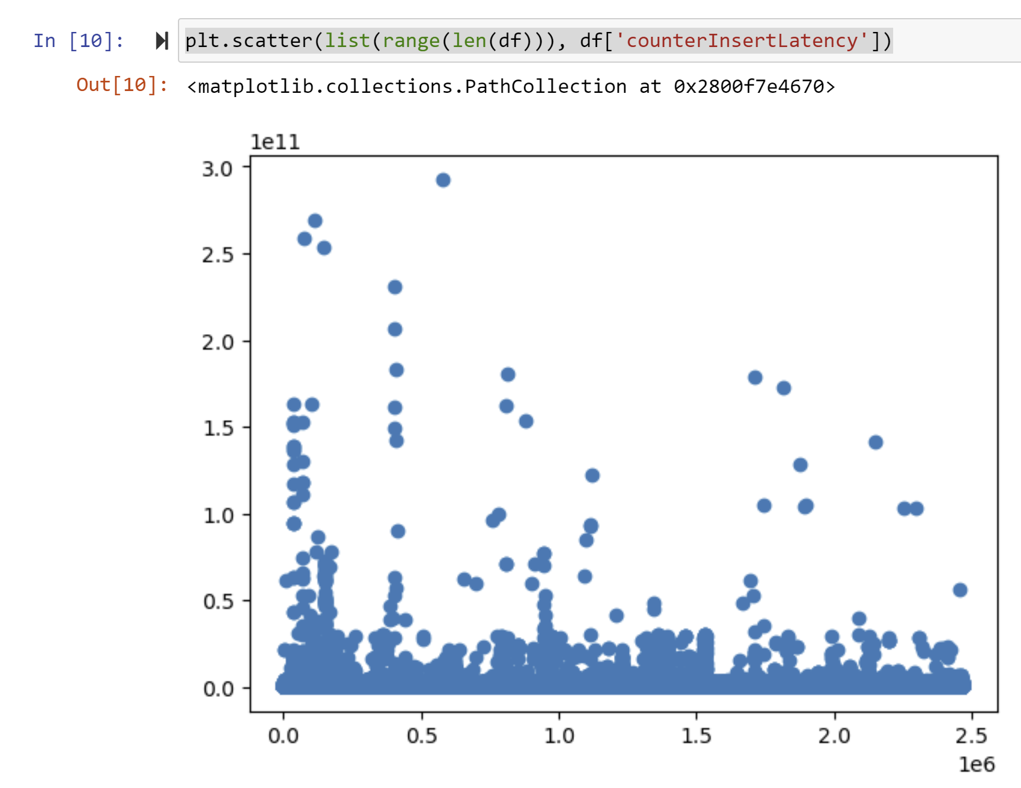

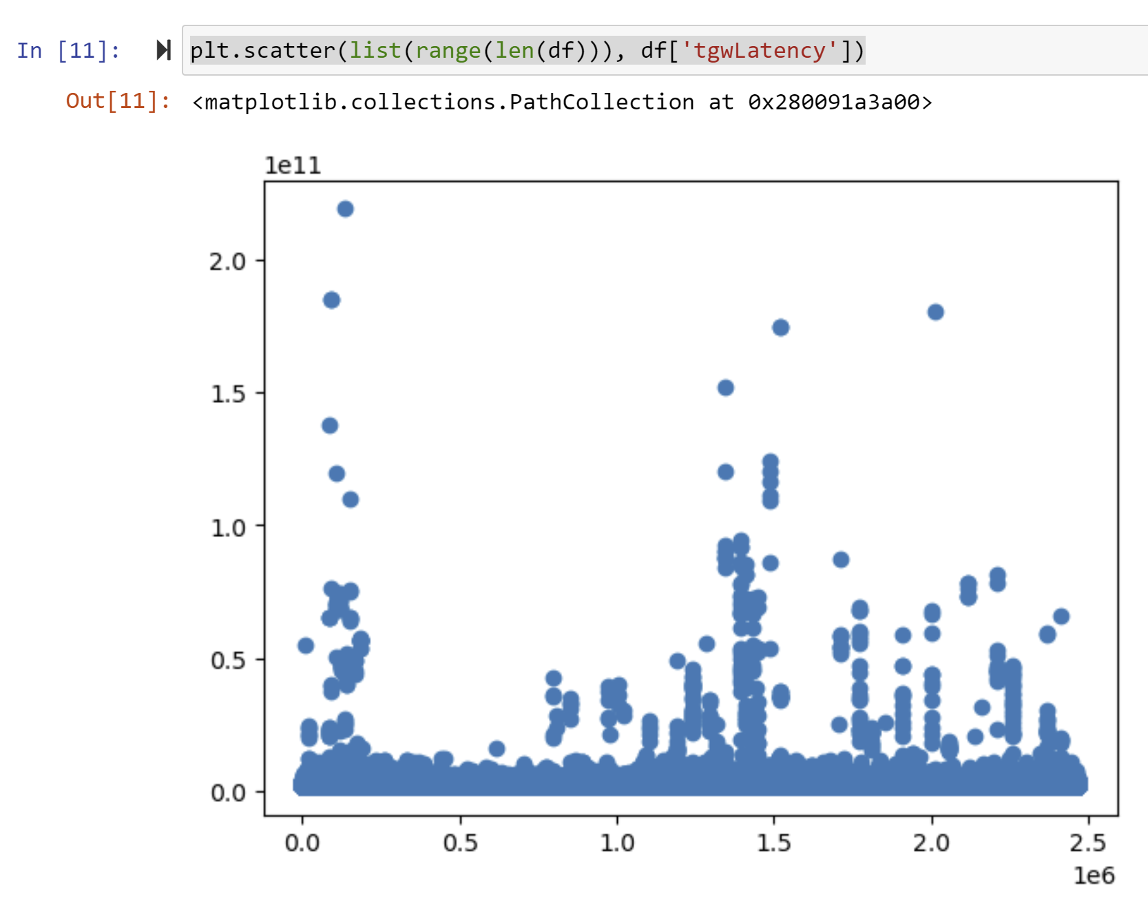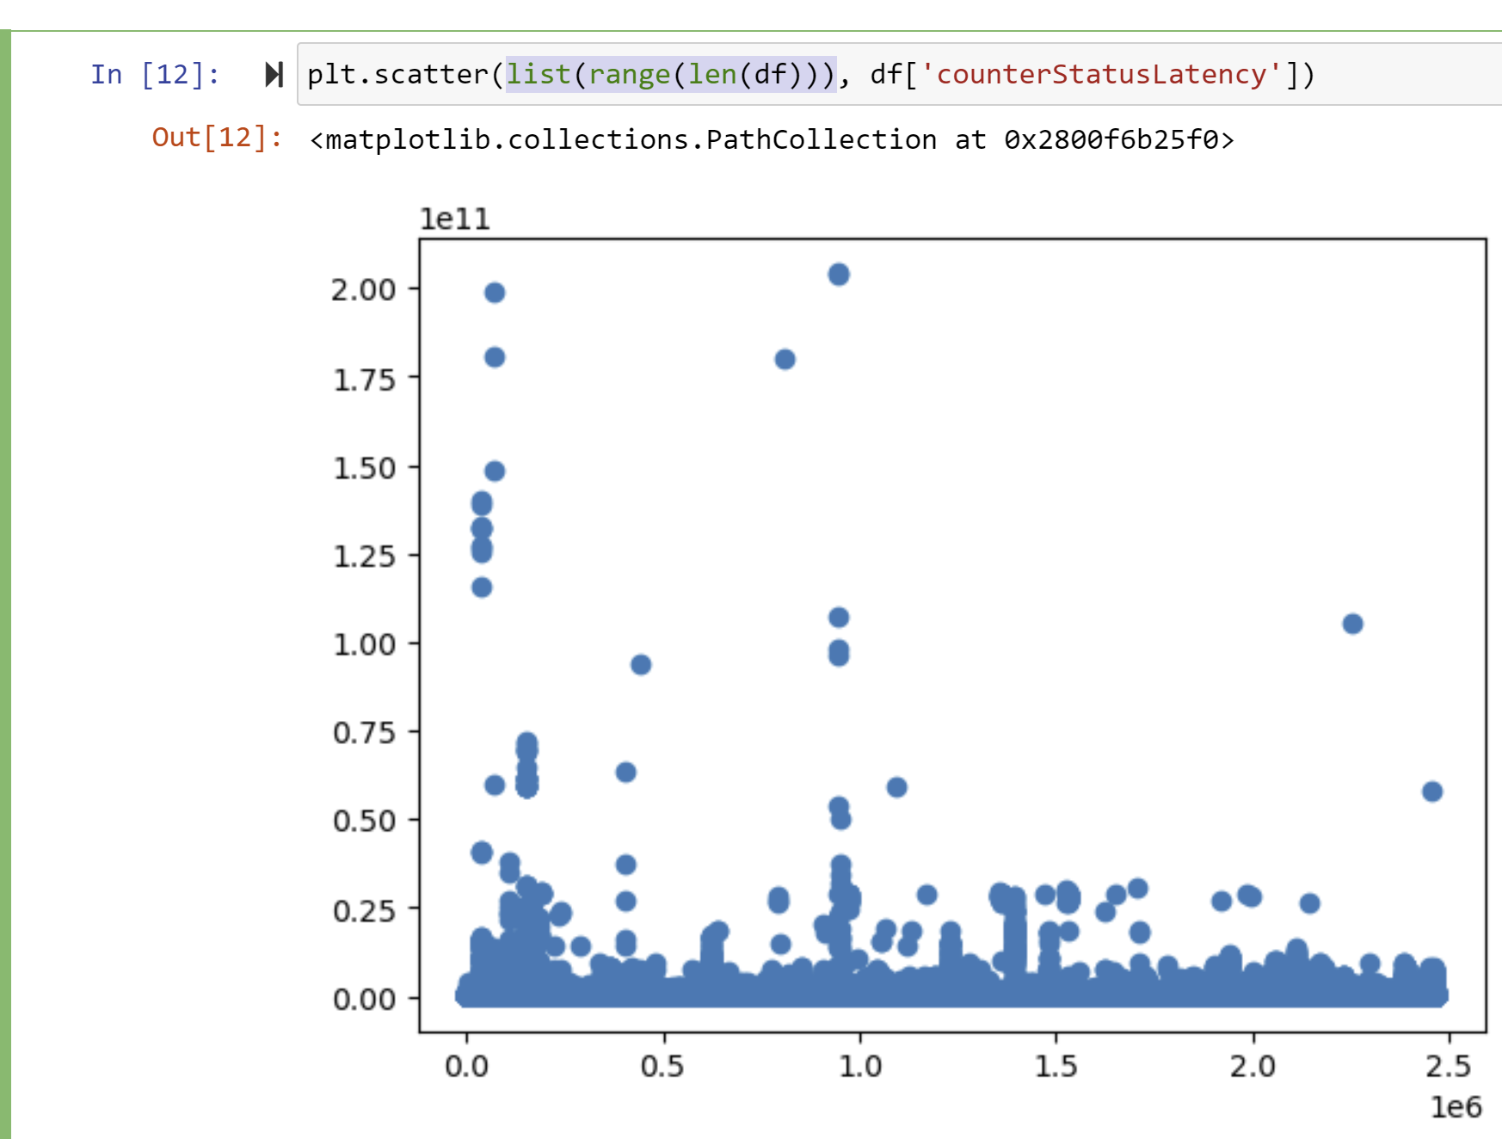

InsertLinkLatency shows us a twin peak distribution, meaning that we probably can’t use the t-test to make sure if variables have an effect on its latency. Instead, I used multi nominal regression and k-clustering to ensure that variables had an effect on the latency. For clustering purposes, I took the number of unique entries in each file, and divided by 5 to input as the number of clusters being used. The most notable changes were from the direction, clientInsertReqLength and clientInsertId, and quantity. There seems to be more latency when there is less quantity in the trade, which probably means that since more people are trading at these lesser quantities, the volume might be a factor in increasing the latency as shown with the left graph when we were determining the distribution. The clientInsertId was further proved when graphing a line chart, showing that there is variance amongst the clientInsertId. There is also evidence that the insertLinkLatency is also affected by the volume of trades being handled at the time. When looking at the last 2 charts, it shows that there is a correlation between a higher latency, and higher density, or volume of trades being performed at the time.

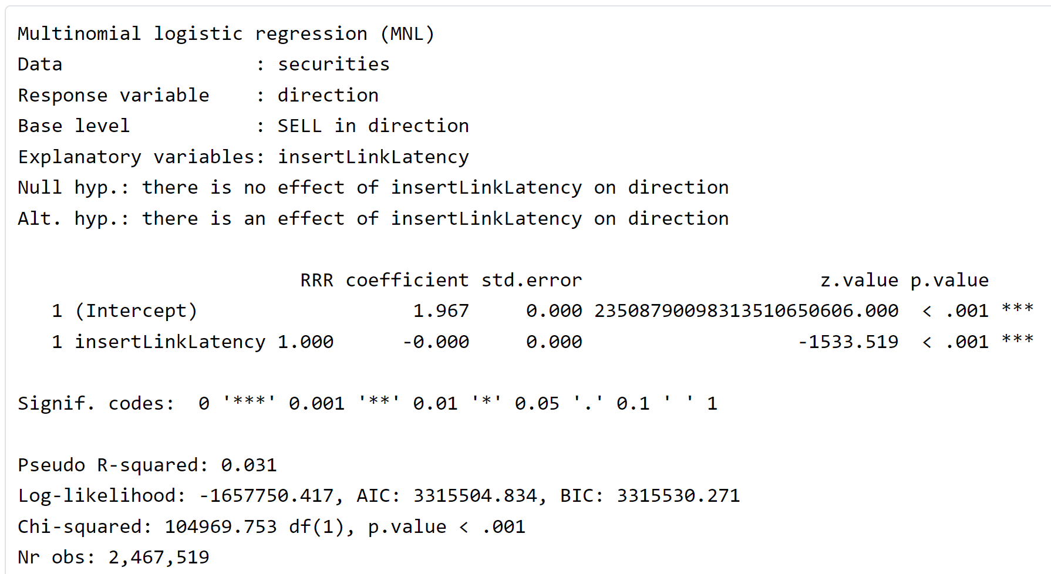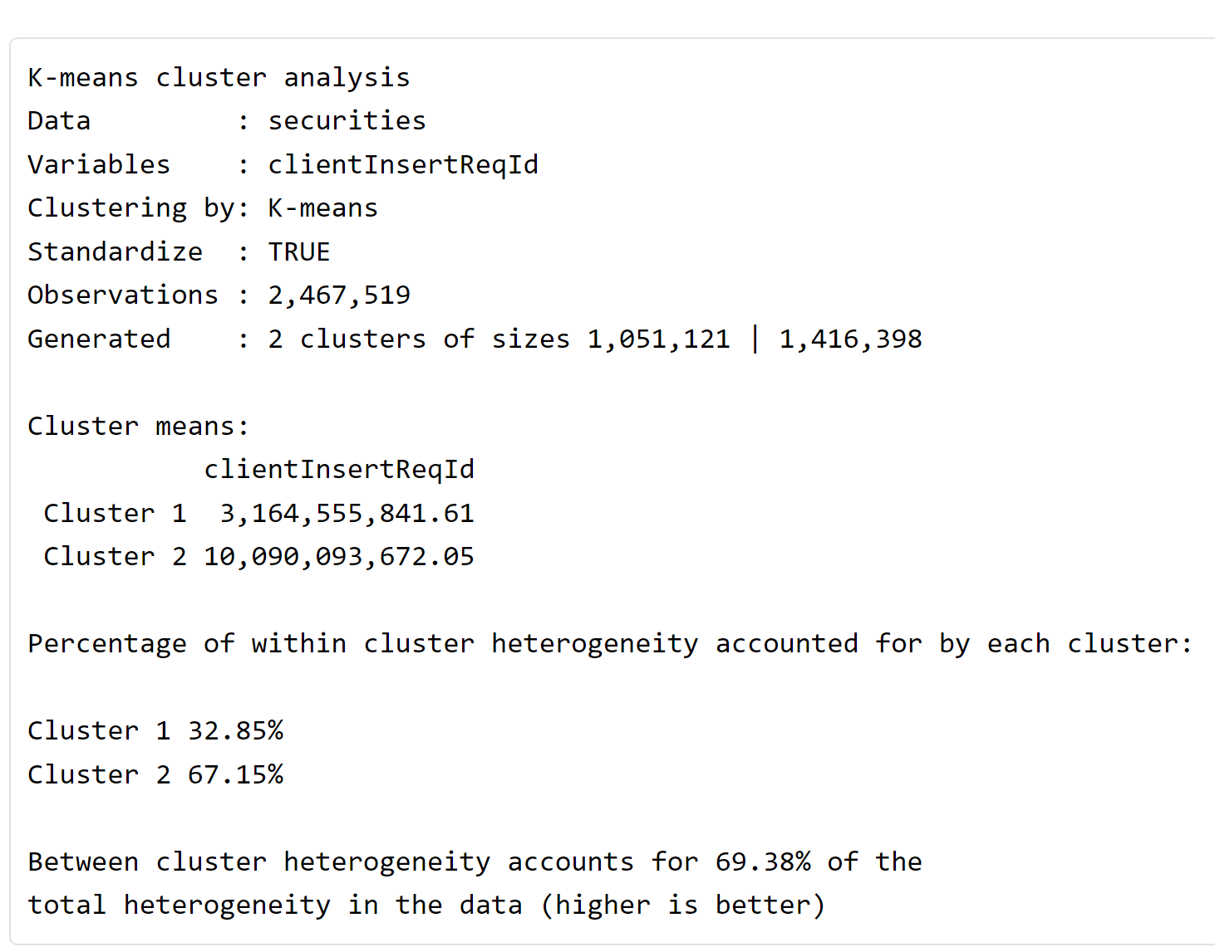 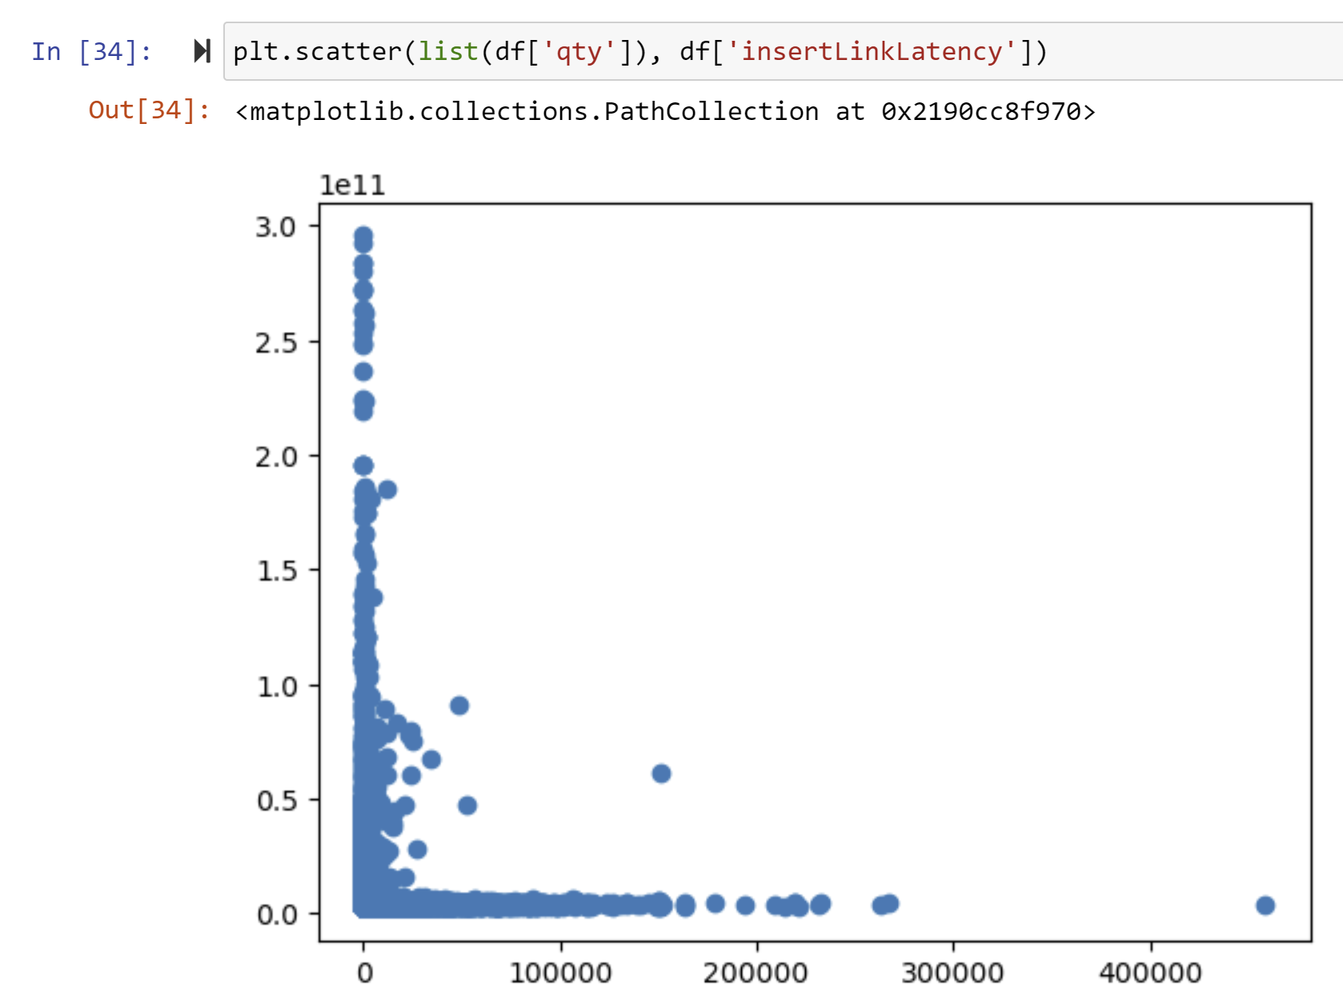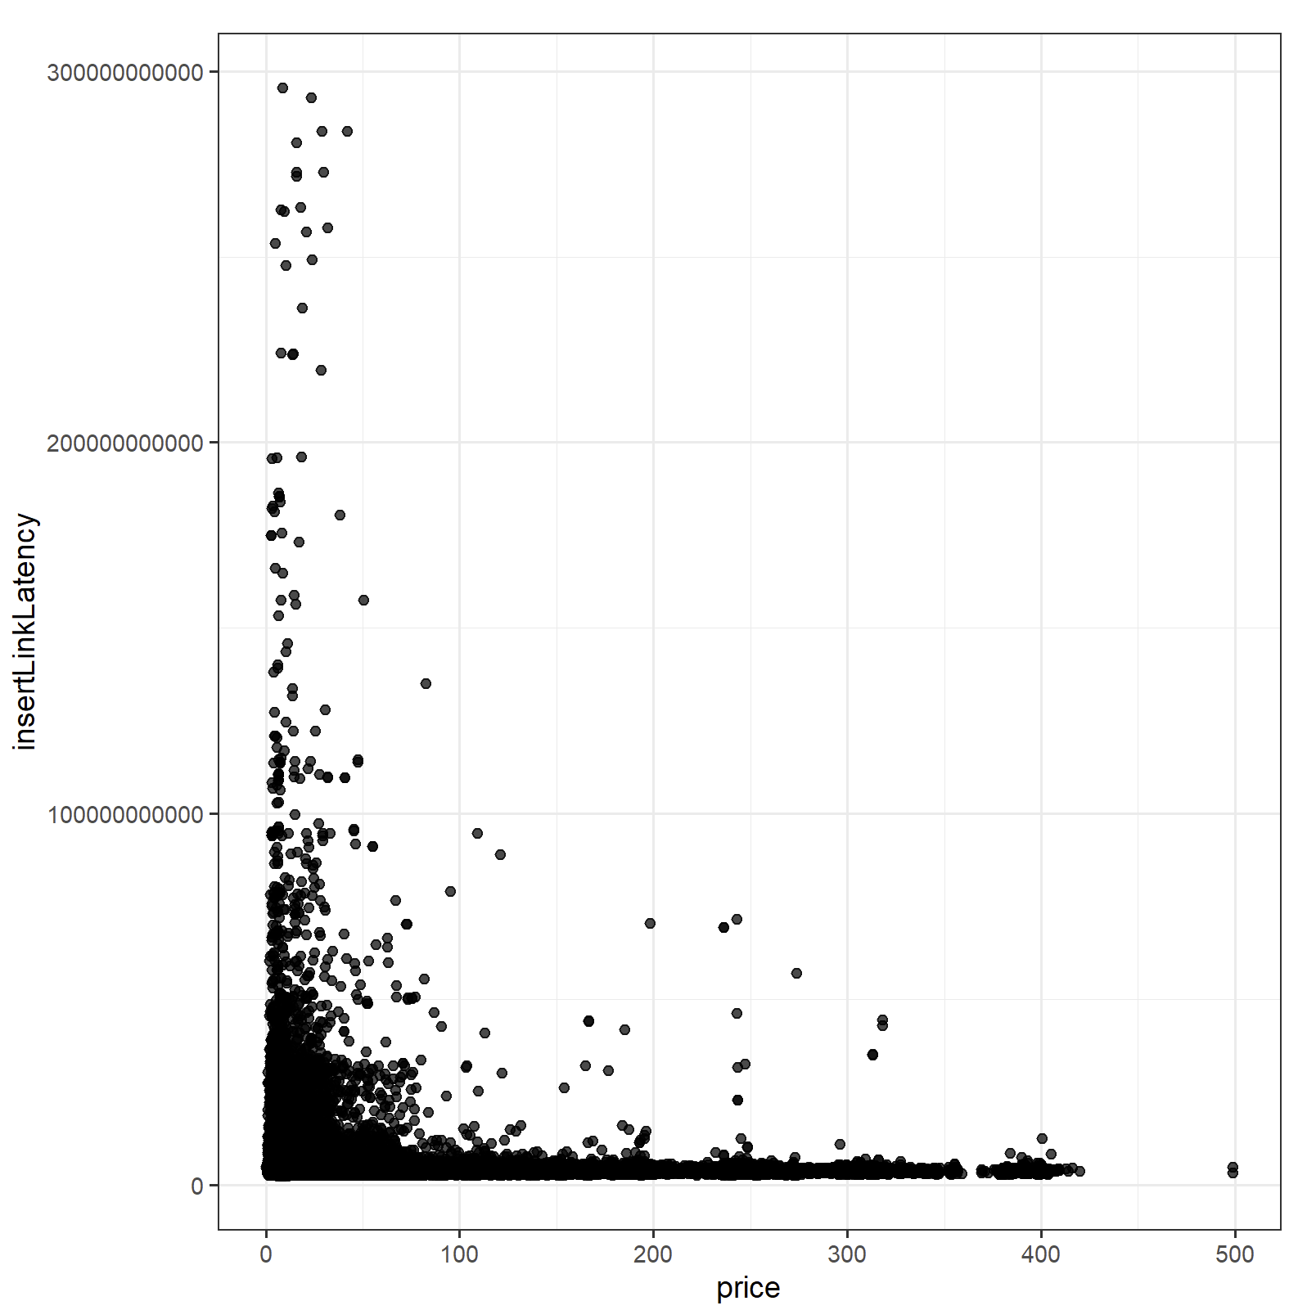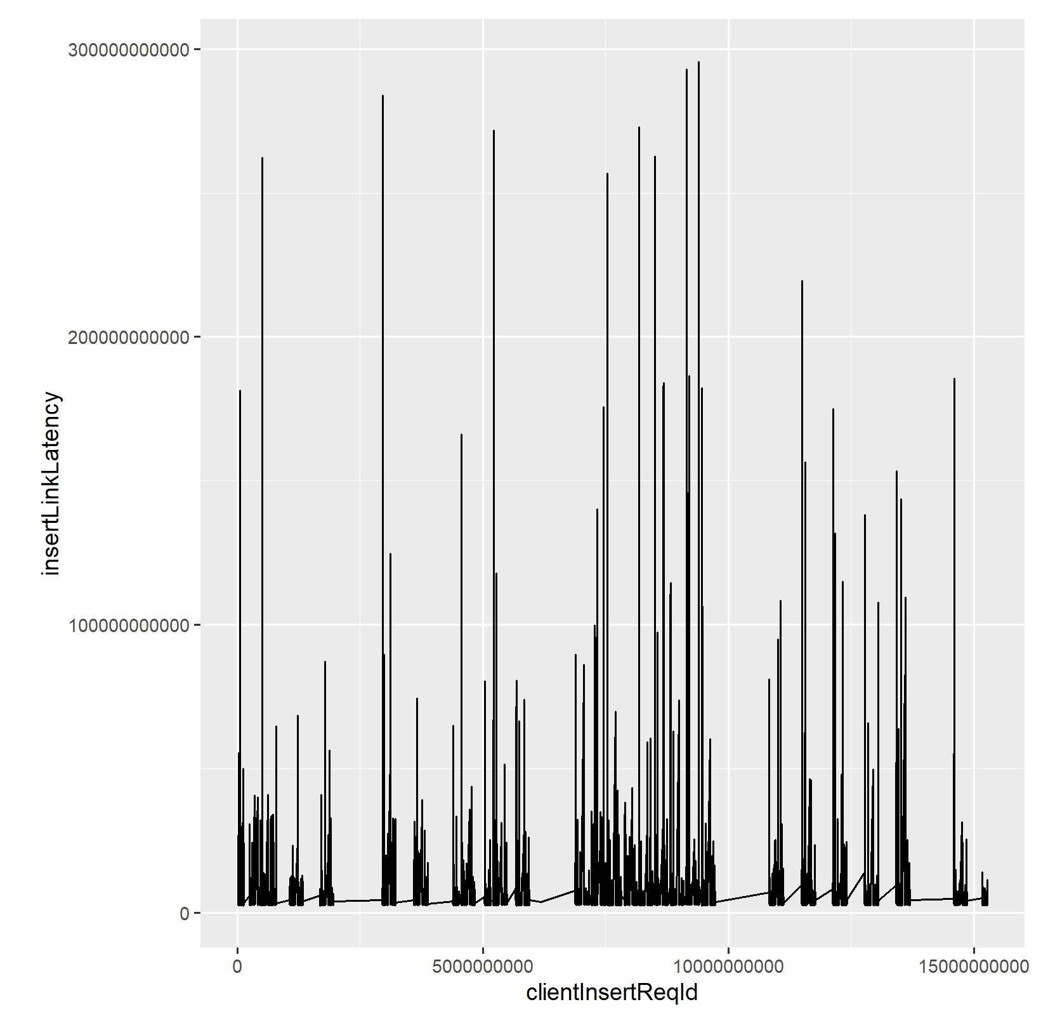 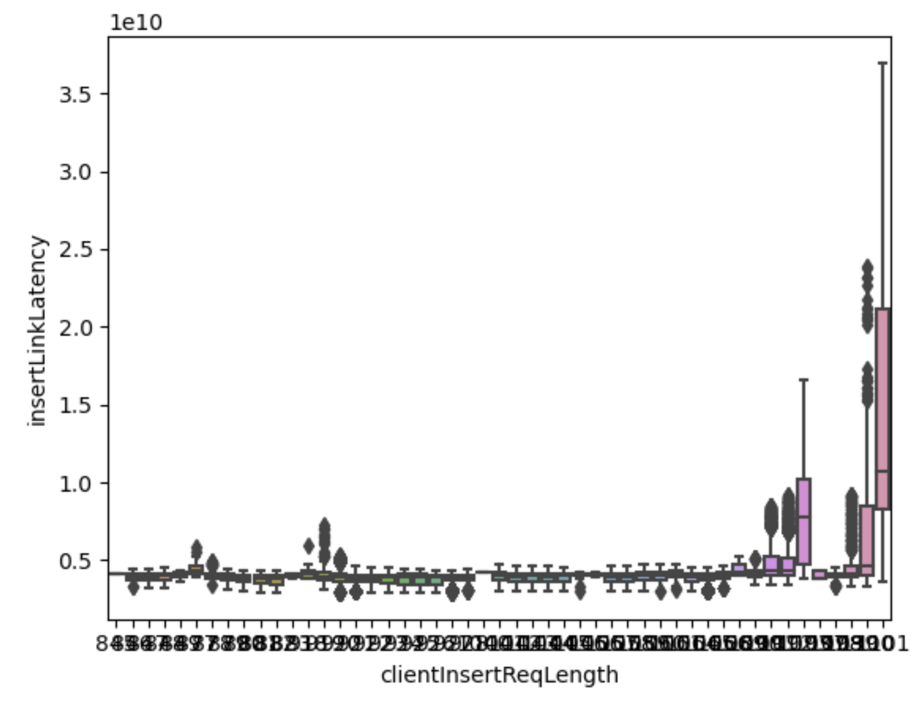

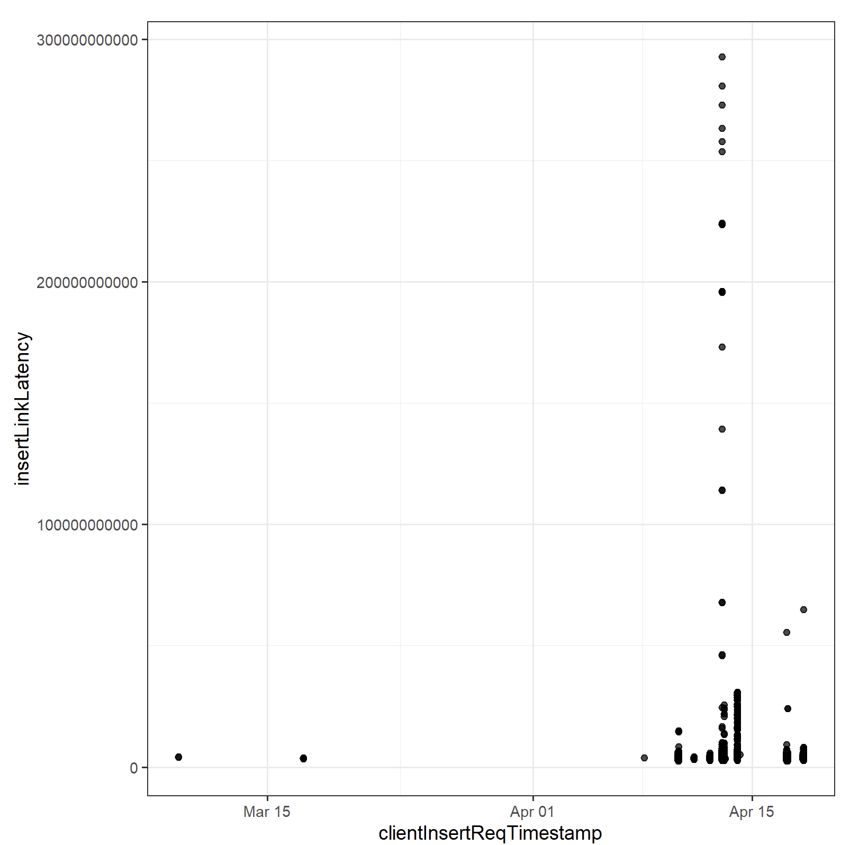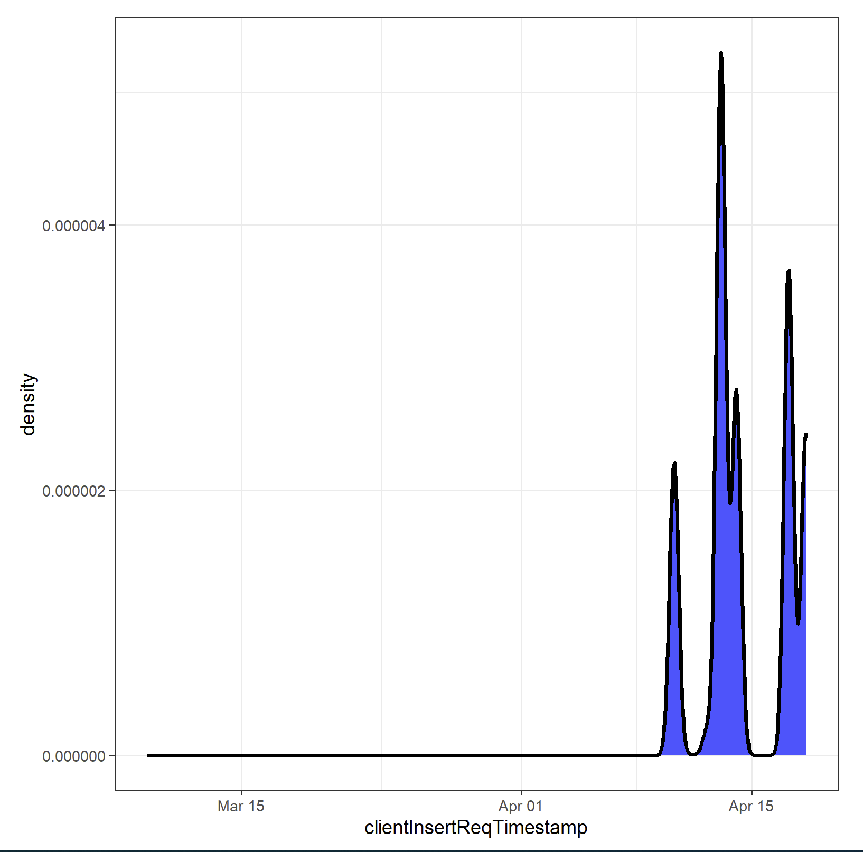

There were a few lengths that showed greater latencies than the rest of the insertReqLengths. One thing that didn’t affect insertLinkLatency was the set, branch, and account Ids. From the median and line tests shown below, all of them are relatively the same. Thus we can conclude that most ID values don’t affect the latency that much.

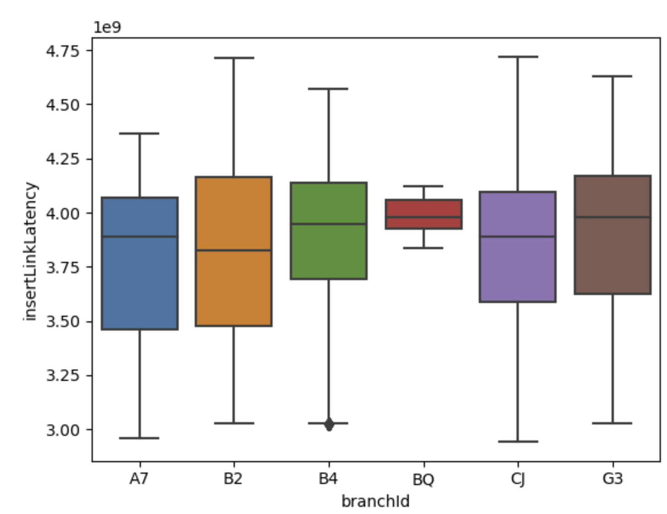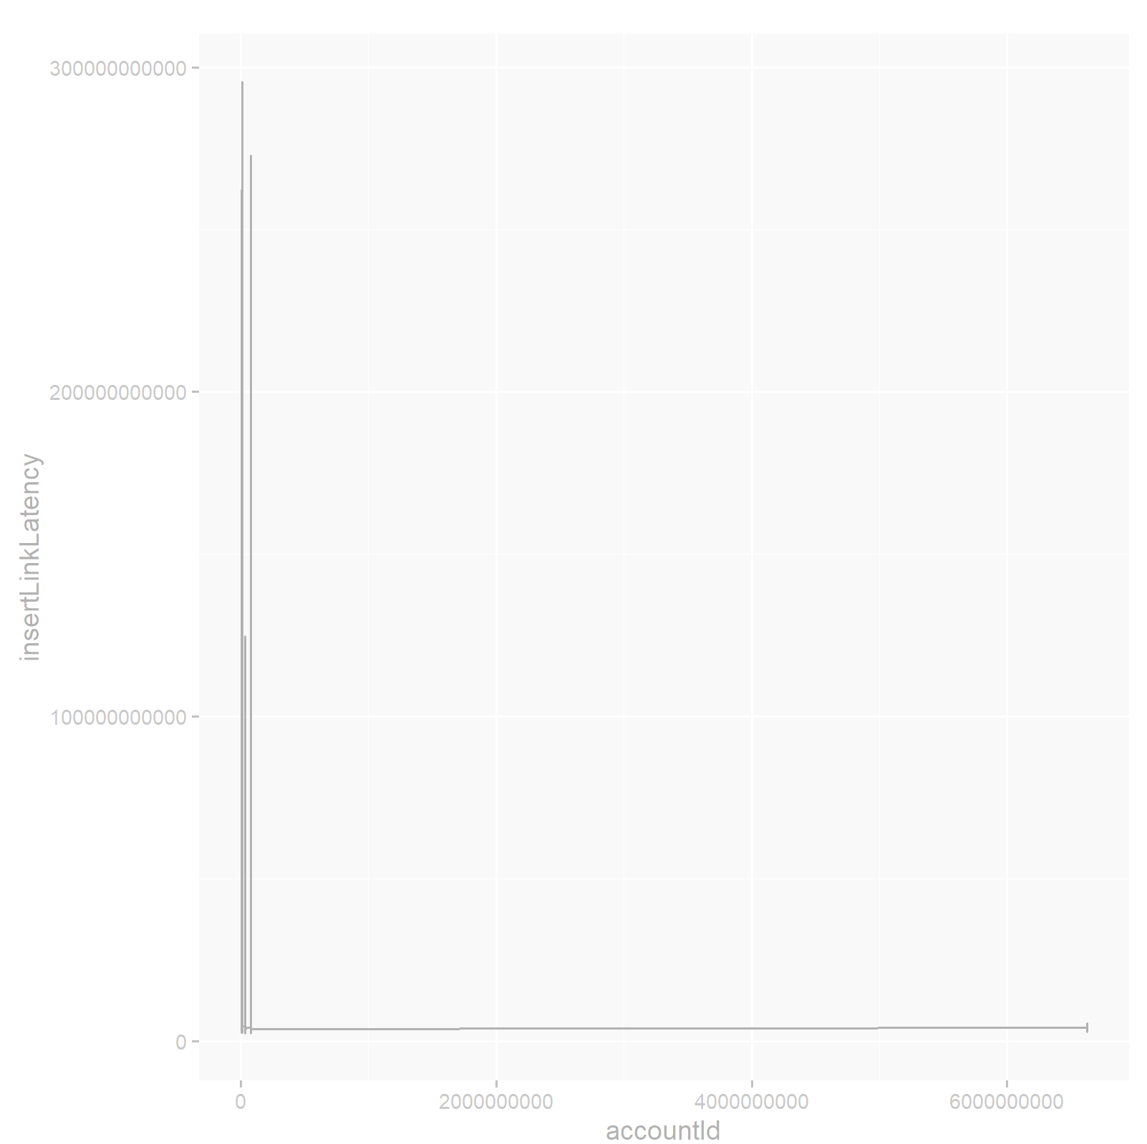

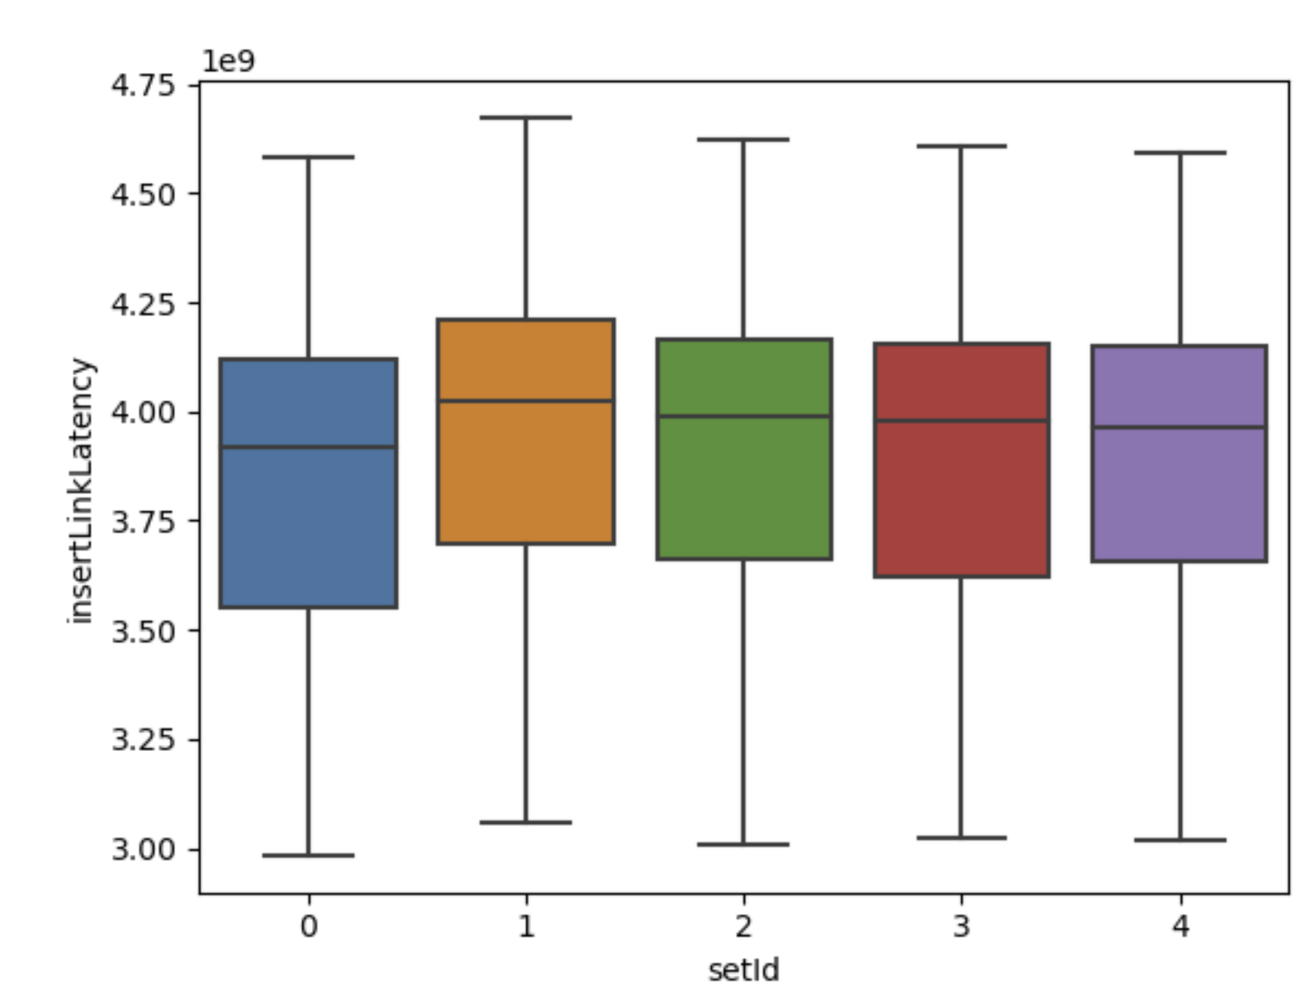

Looking at counterInsertLatency, it shows that the effect of the explanatory variables in requested, insert response it, and insertRspLength, which all show that there is an effect of these values which affect the counterInsertLatency. 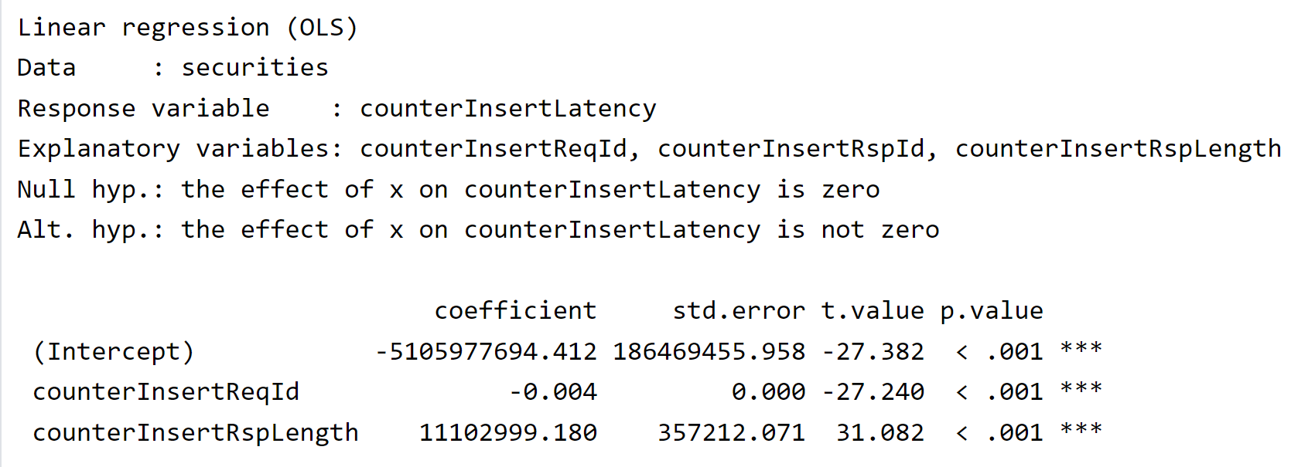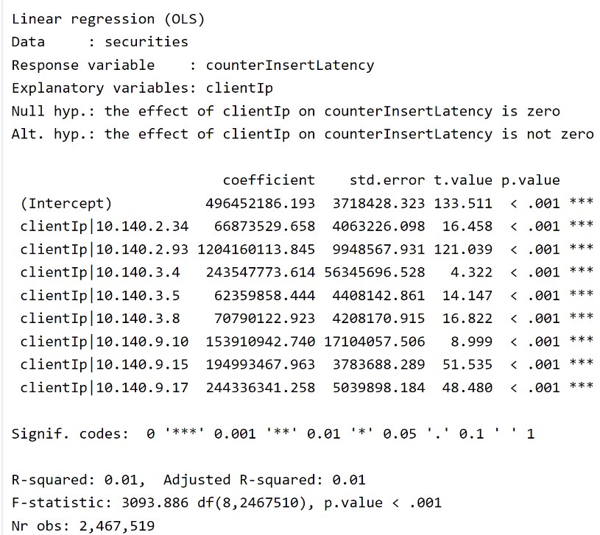Other variables I looked at were the branchID and some of them had significant effects on the counterInsertLatency variable, as most of them had P-values below 0.1, and this meant that the branchID would also have an effect on the latency of the trade being made. A sell or buy order also had an effect, as seen in the chart below, but the ordertype variable seemed to have no effect on the latency. Similar results would occur with the response variable being counterStatusLatency. The counterInsertLatency also could be affected by the clientIP address, it is a factor with all p-values being below 0.1, which means all of them can affect the response variable, and the adjusted R-squared value can be ignored since it is not a numeric variable. If the security is a sell order, it seems like it would have a lower latency than if the order placed was a buy order. The orderType seems to not have an effect on counterInsertLatency and also counterStatusLatency as the p-value is extremely and greater than 0.1, meaning there is little to no evidence against the null hypothesis. It seems the 3.4 ending IP address has the lowest latency, while the 2.93 ending IP address might have the highest latency when trading futures. The direction variable also has a significant effect on the tgwLatency the R-squared value showed that there is a relationship between them, and the p-value shows that there is significant evidence that the effect of the direction on the tgwLatency is not zero. The low adjusteted R-squared values can be explained by how the largest fundAccountID or some other numerical value does not hold the largest/smallest value, and the numerical value in the middle might have be holding those values, decreaseding the adjusted r-squared relation value. There are also certain branchIDs that don’t affect the counterInsertLatency, showing that maybe some branches are slower such as G3, but others are faster such as B2, which the company can look into further to explain why. Another observation is that the volume of trades can also affect the counterInsertLatency as there is a higher amount of trades happening around April 15th. 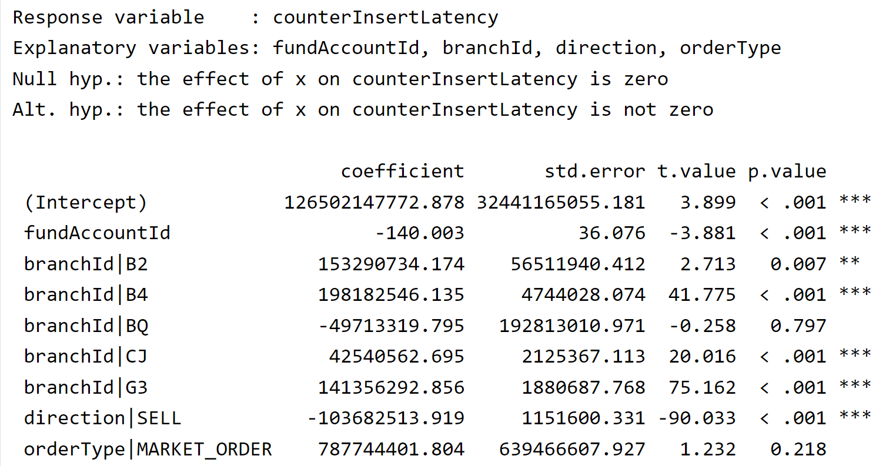

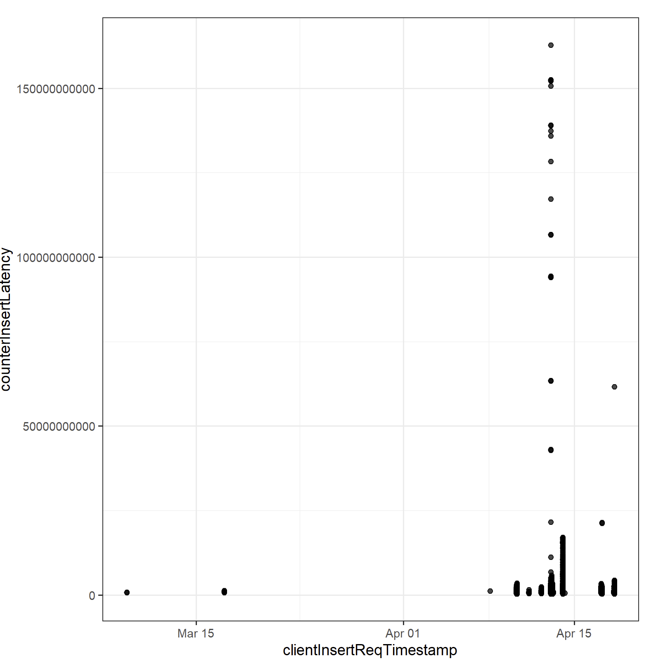

Factors that are irrelevant and seem uncorrelated to the latencies were the insertLength and the insertId’s were bad predictors in determining whether there was a higher latency in their respective fields. This is proven with a low R-Squared value.

For the tgwLatency, This needed to use the clustering method in order to determine if certain attributes did change that were numerical dude change the result of the latencies. From the clustering method, it seems like there is a difference in the tgwLatency when the tgwId is different, which is reflected with a 98% hererogenity score. For the other categorical variables, I used a logistic regression technique to find whether there was a difference within the factors. Most notable tests include the direction, quantity, and clientId as the ones have the most effect on tgwLatency.

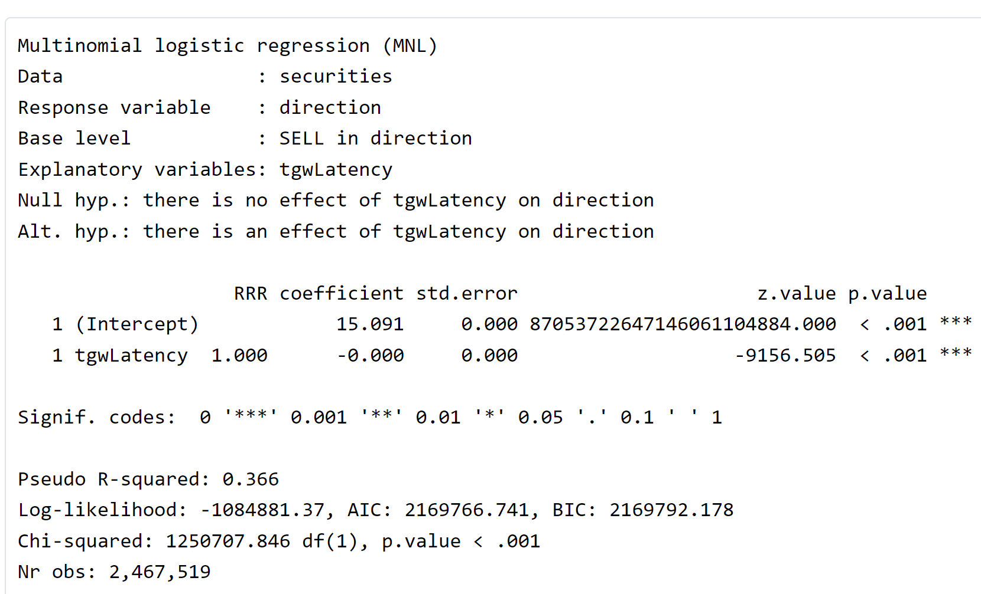 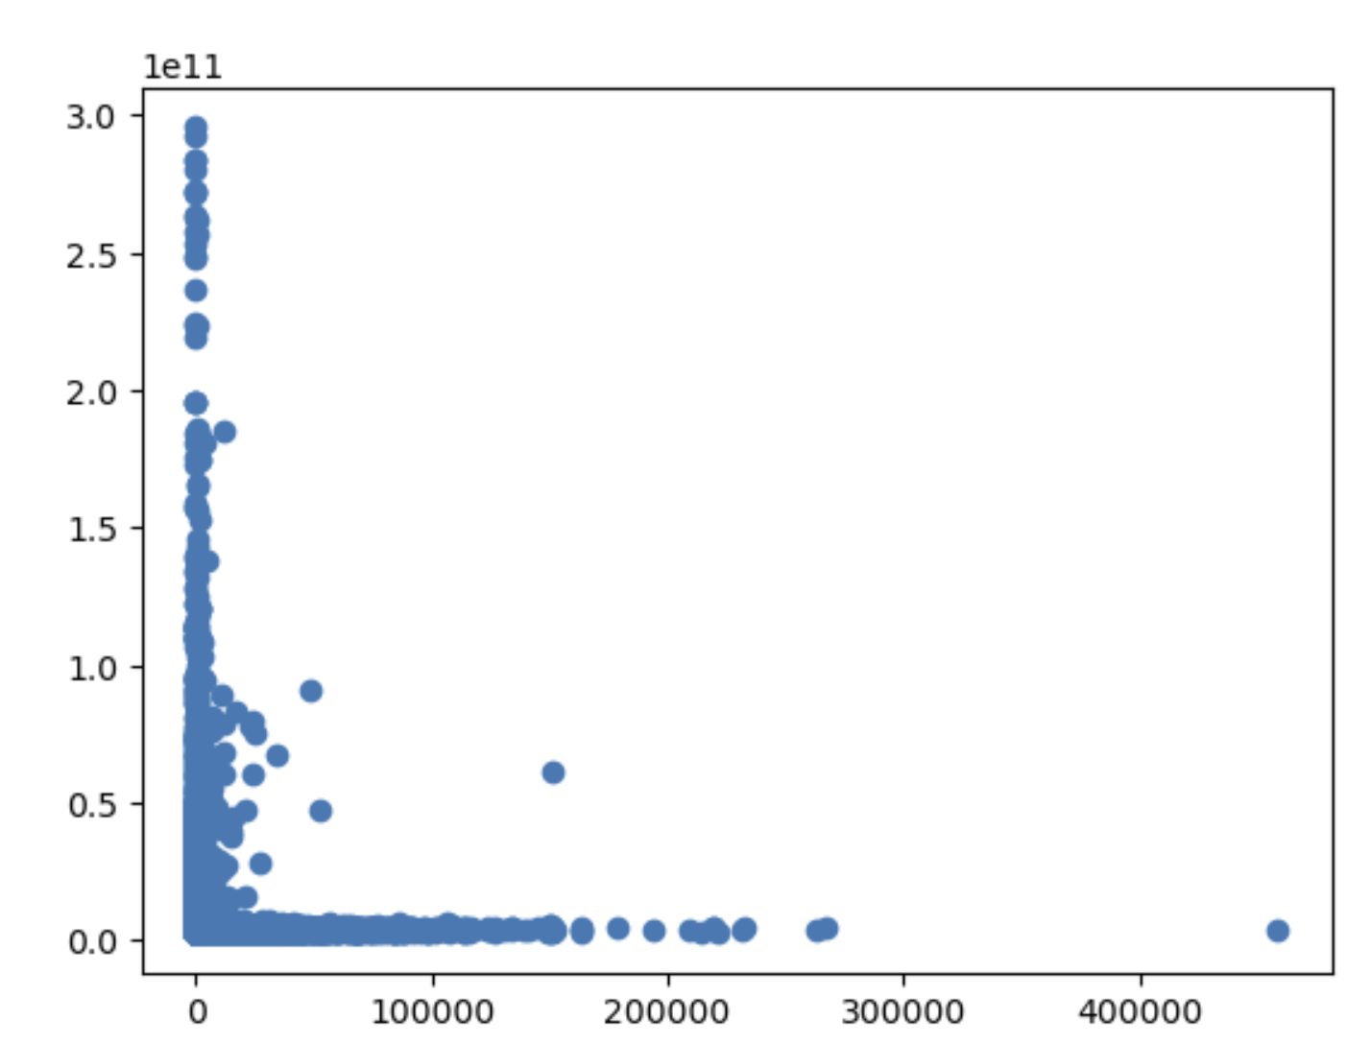

Below is the clientID, and the timestamp with a line chart. Something surprising is that there is a higher latency on the date around April 15th, which might be something to note, which is true when you look at the density graph for the time at the date around April 15th.

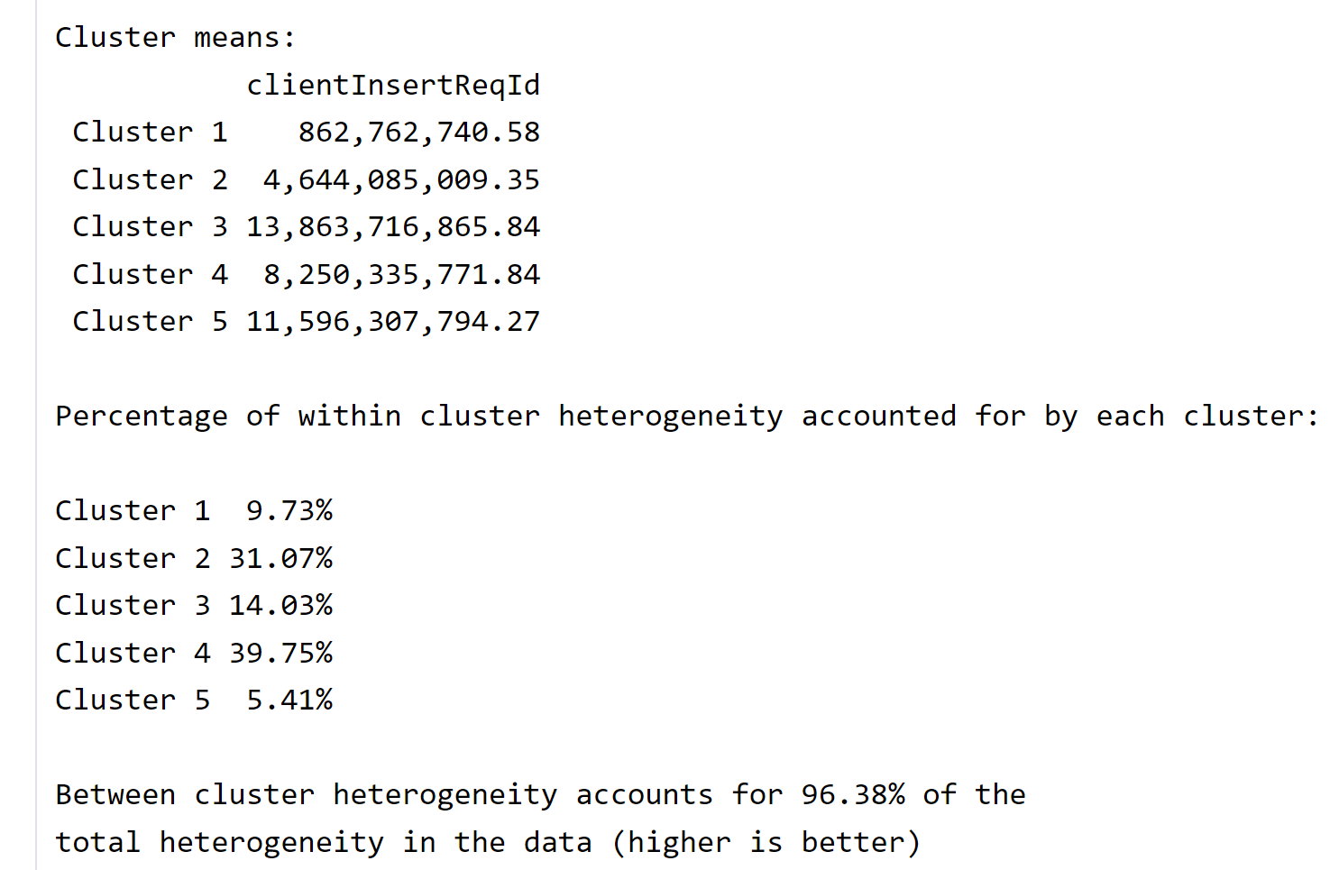 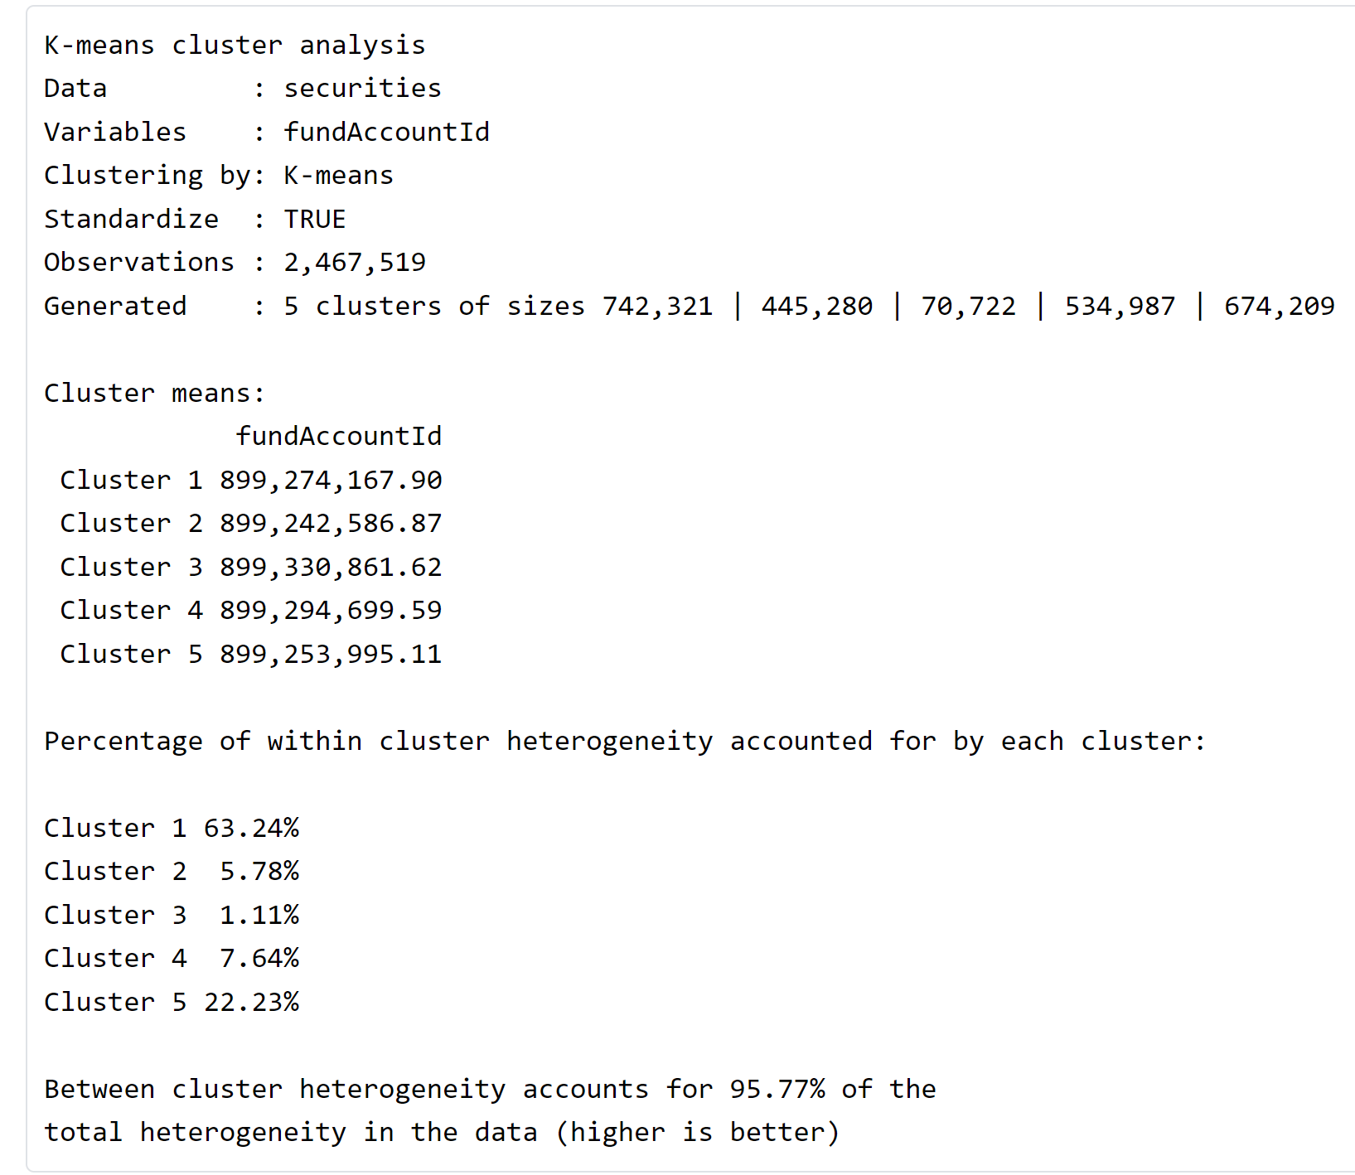

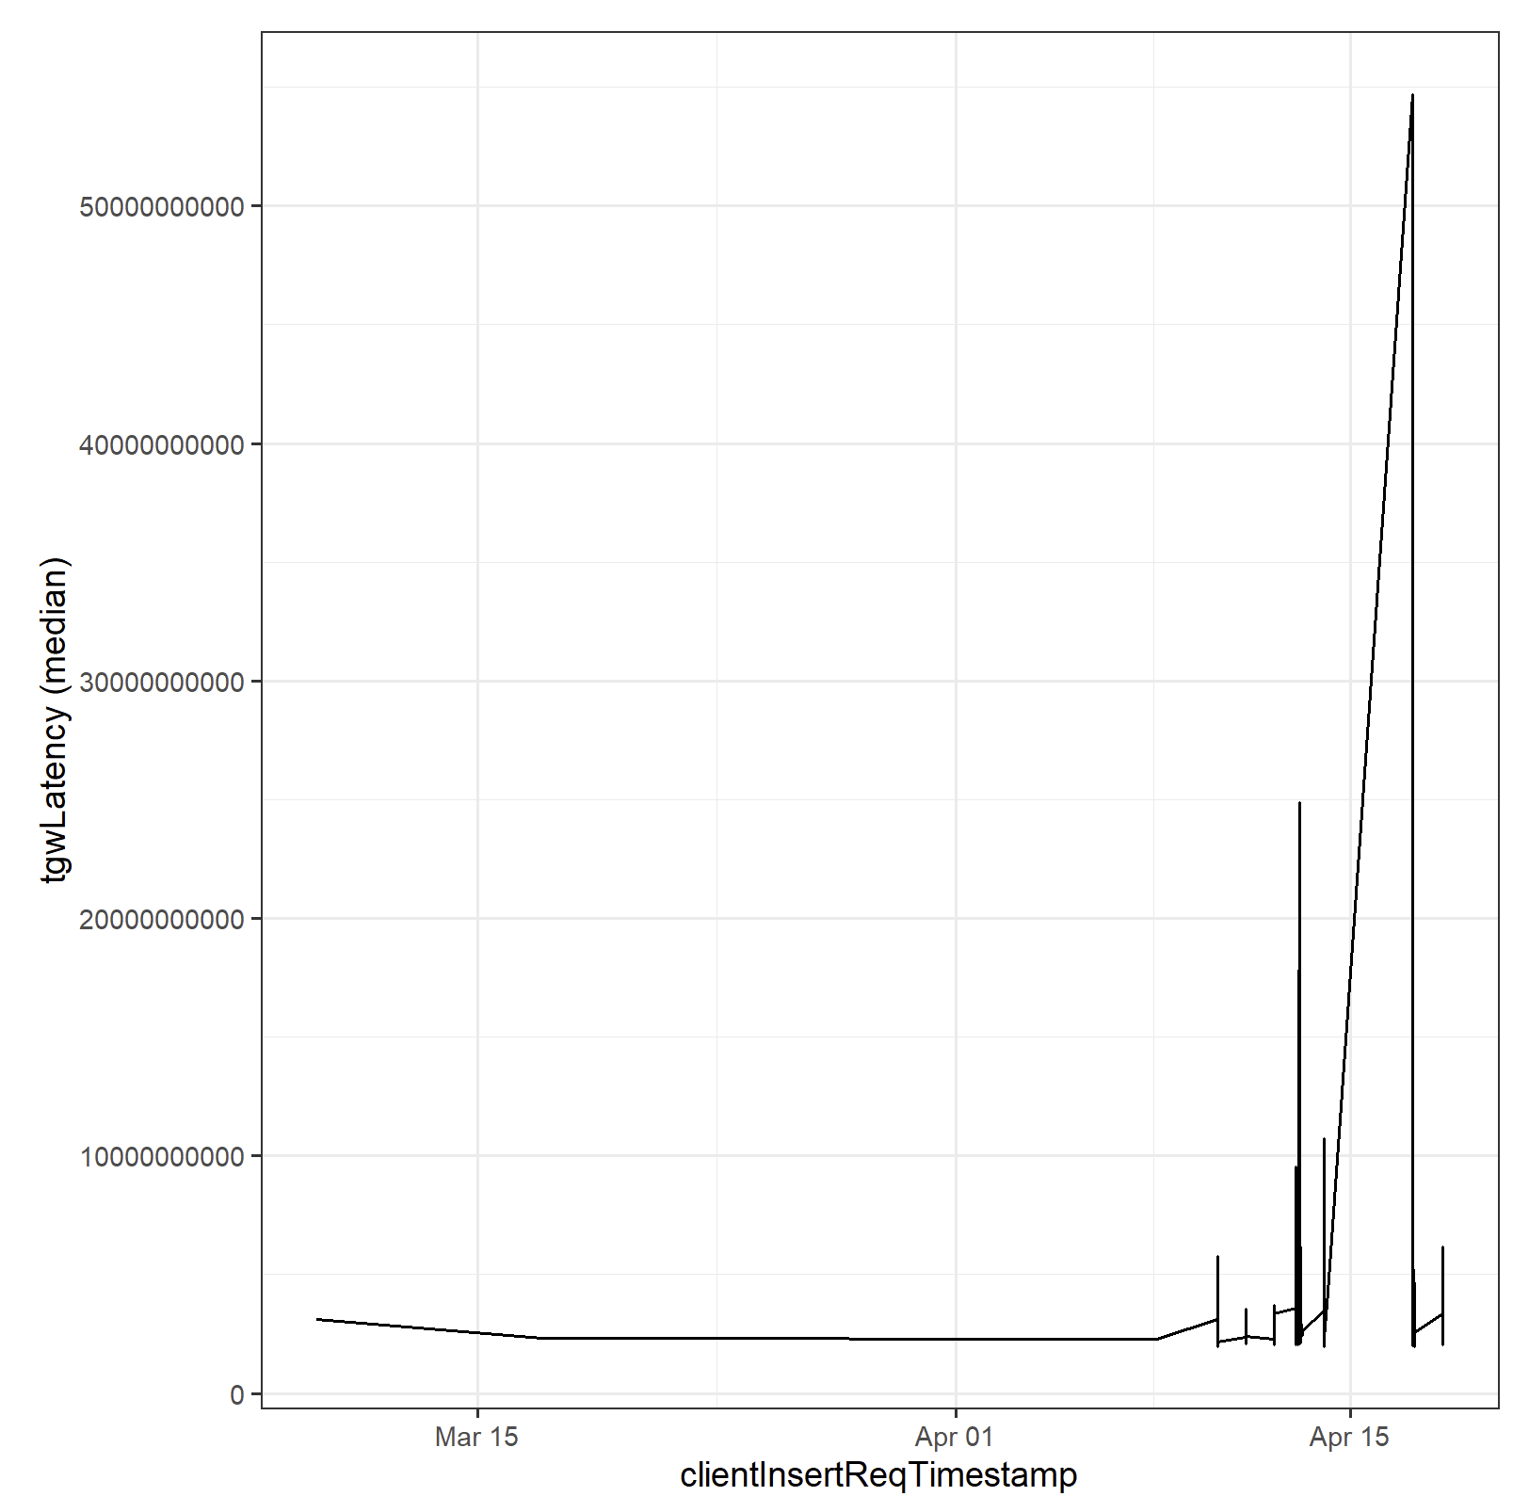 

It also seems as if the direction variable has an effect on the tgwLatency as shown from the R-squared value. One thing that might have affected the Latency was the branchId, as looking from the median, the B2 branch has a significantly lower median time than all the others. With the many observations in each branchId, we can conclude that maybe B2 might have some effect at reducing latency. Things that don’t affect the tgwLatency were the other Ids, such as the setId, execId, and reportIndex.

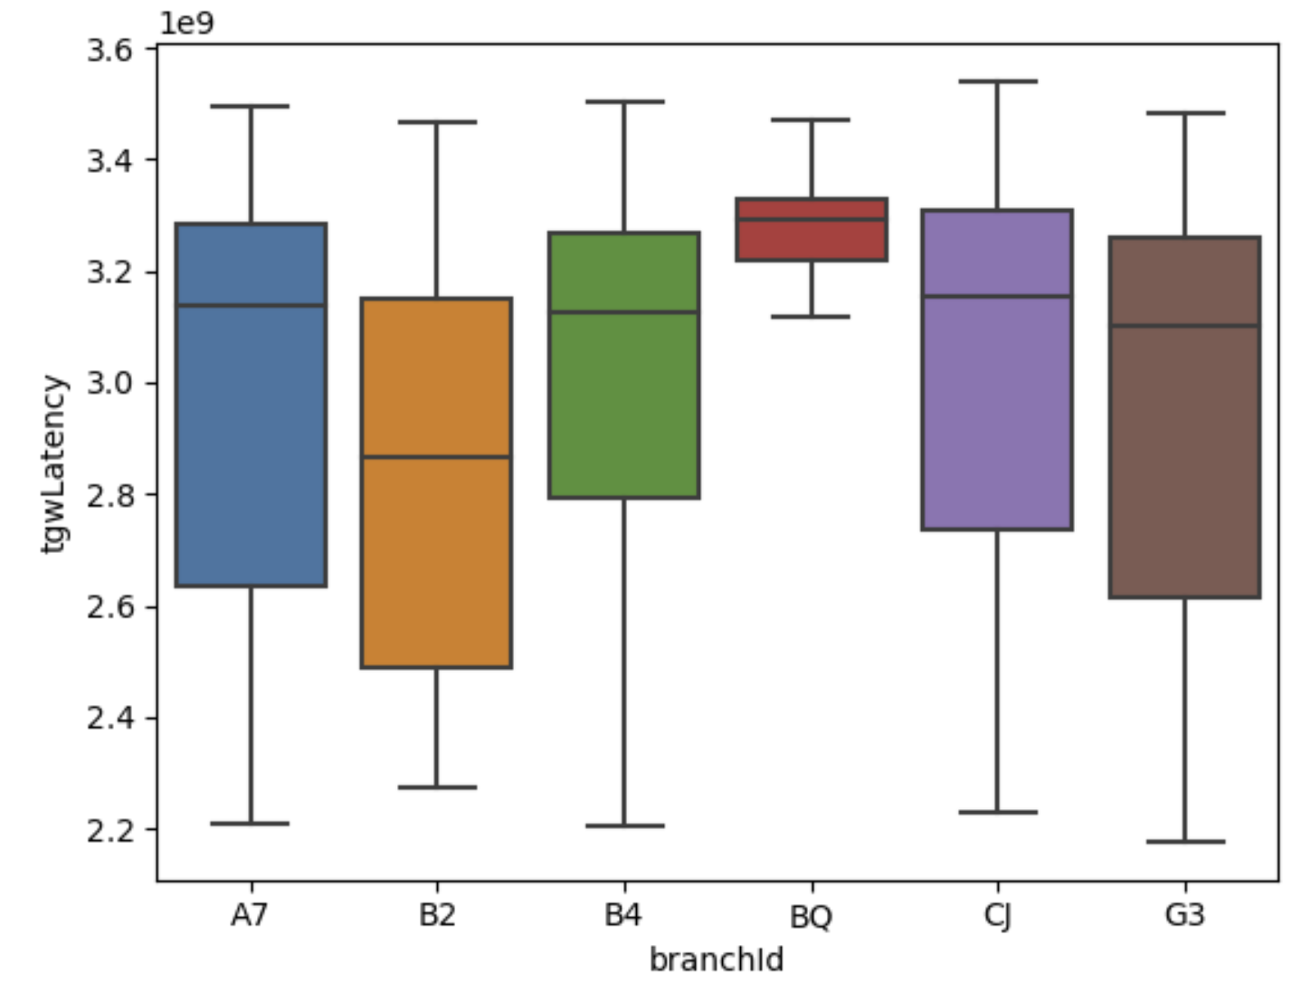 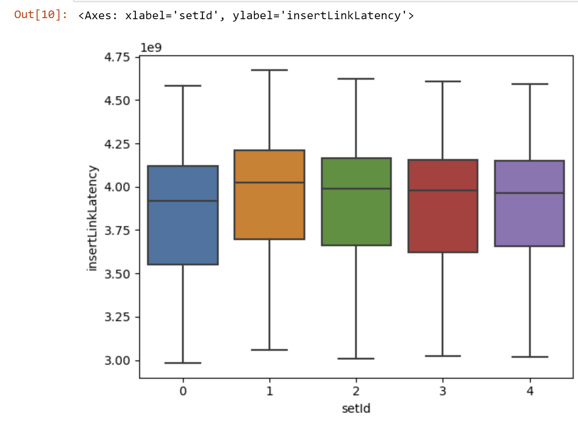

For the counterStatusLatency variable, it doesn’t seem as if many of the variables or a combination of variables show a correlation between them. Although many of the variables provide a low p-value indicating that the variable may affect the counterStatusLatency, the adjusted r-squared value remains near 0, which shows signs that the model is not effective at explaining the target field. The setId, branchID, direction, quantity and price variables all don’t affect the counterStatusLatency, as the p-value for them are high, and proves that they have no effect on the response variable. The transactionTime and direction variable are both effective, but looking at the adjusted R-squared value, it shows that there is limited explanation about the variable of the response variable’s data being explained by these explanatory variables. This also might be an issue which a numerical data entry such as securityID, where securityIDs that are not the largest or smallest might hold the fastest or slowest trade times, allowing the R-squared to be close to 0. The volume observation also holds true as there is a higher volume of trades around the date April 15th. 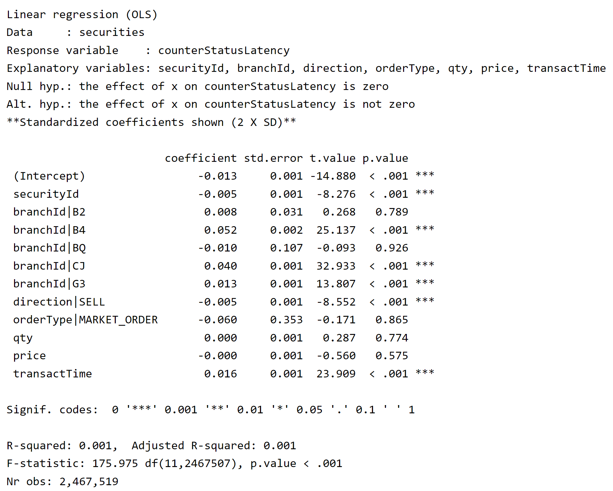

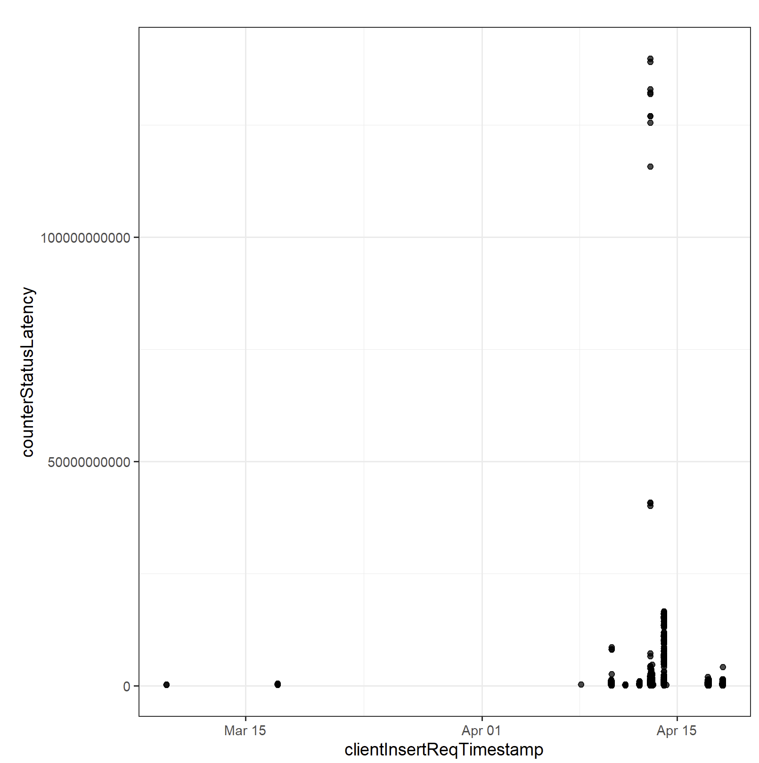

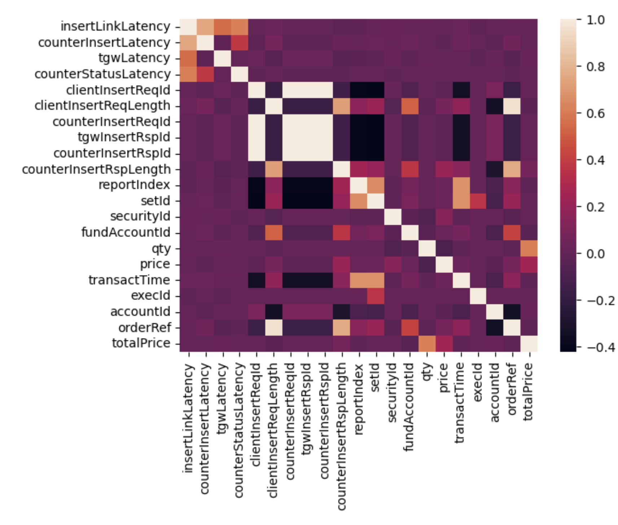

The heat map also shows the correlation between the variables, with the lighter colors meaning more correlation and the lighter colors meaning less or no correlation, this is the chart for all numerical values. From the heat map, it shows that there aren’t many numerical values that correlate to the latencies, but they might have an effect on the result of the latencies.

Another factor we looked at was the time of day that the trades occur, and it shows that time and the volume of trades also had an effect on the latencies. From 0 to 0.2, it seems like there is the most trades during that time, and it shows that there seems to also be a higher volume of trades during that time, which can also affect the trading time.

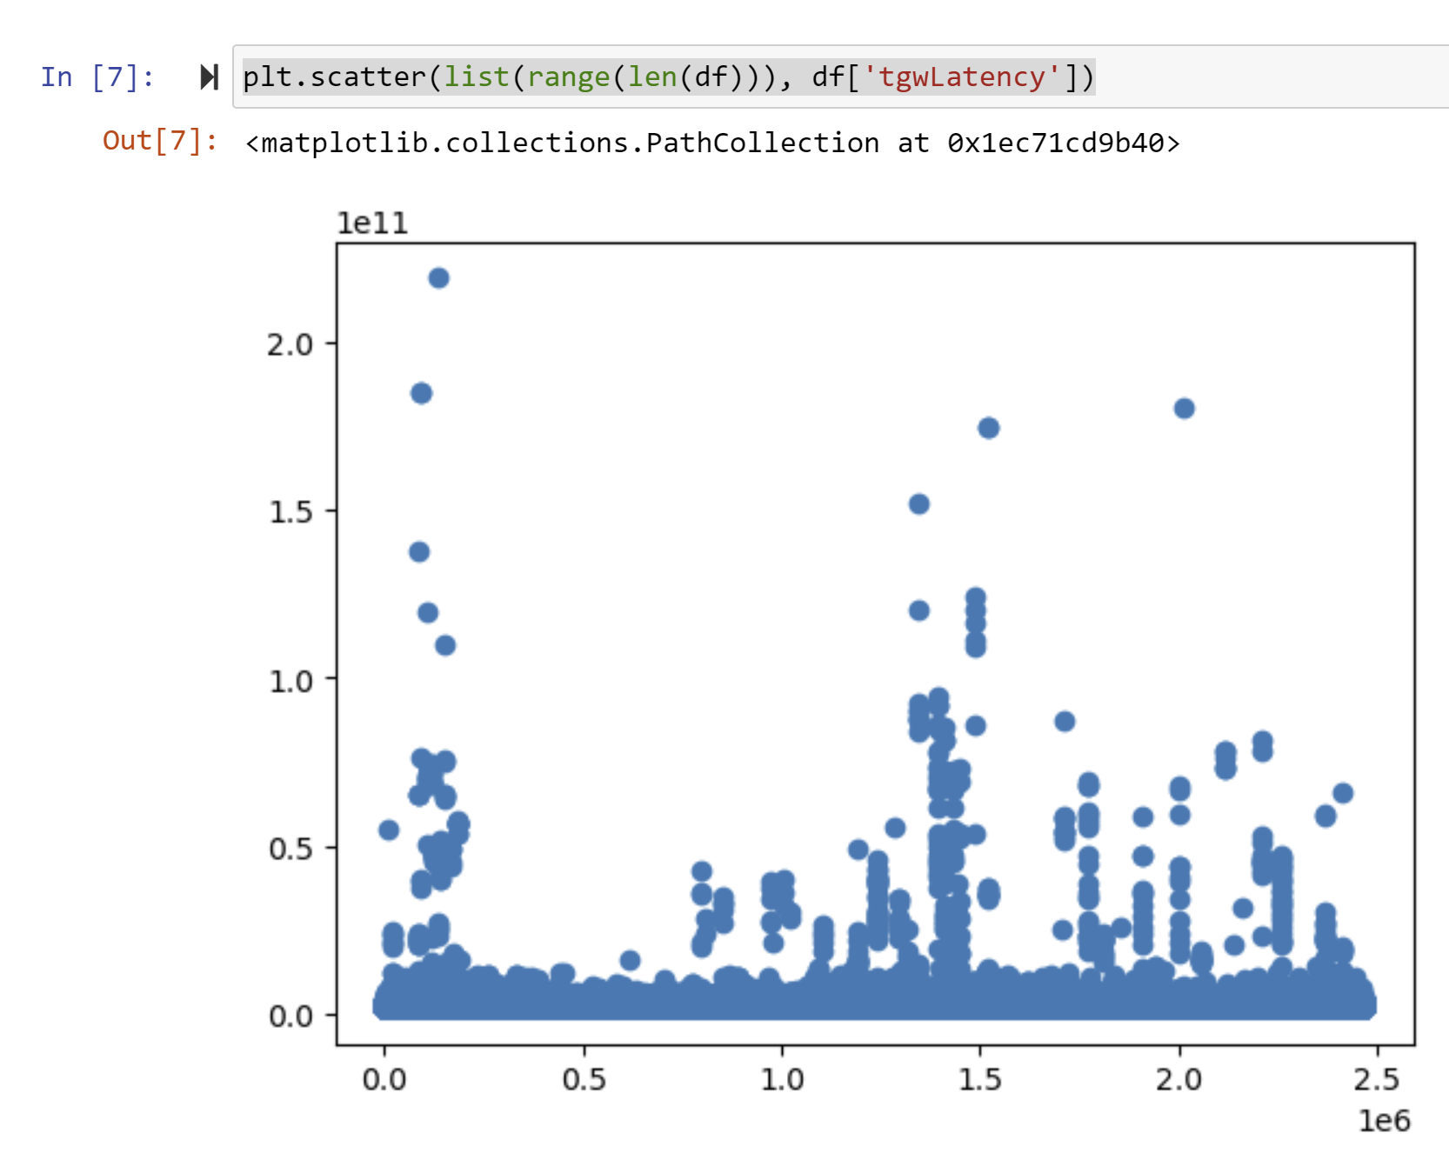 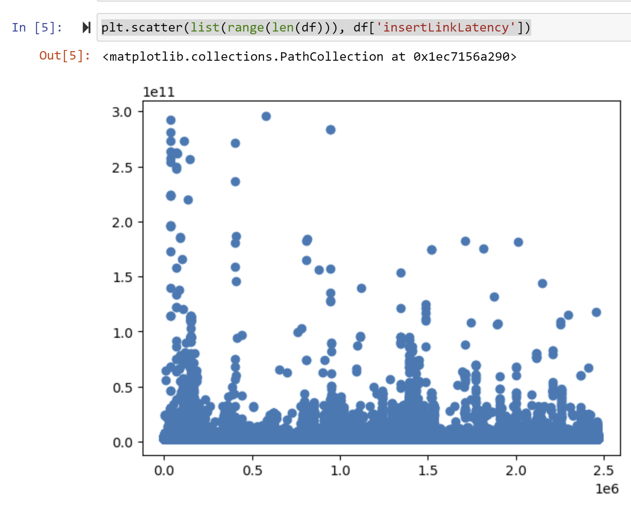

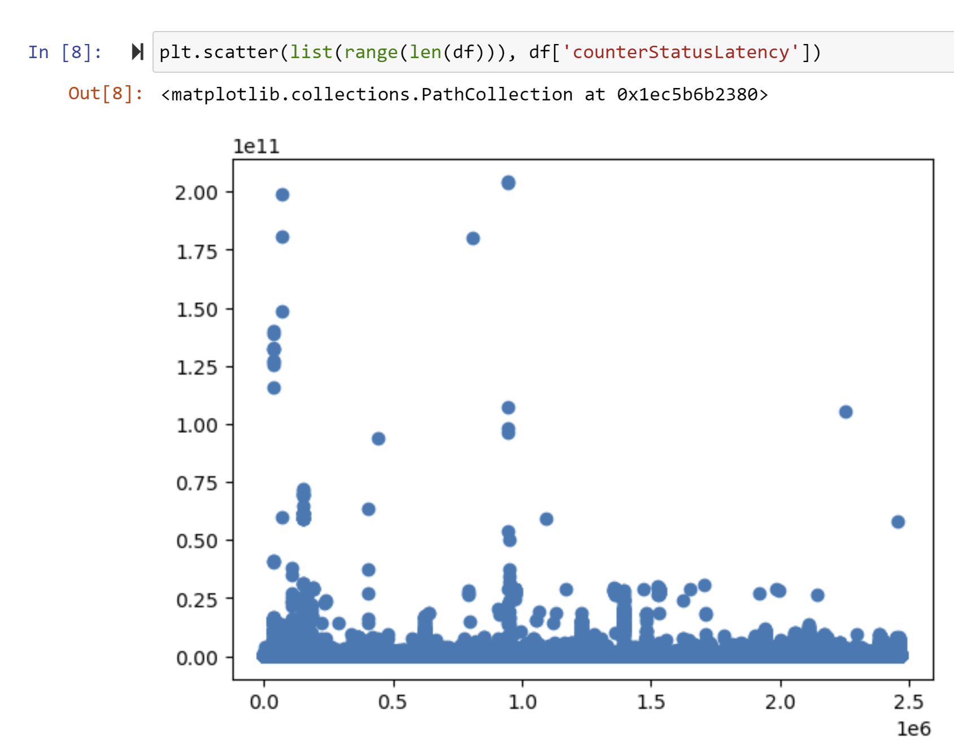 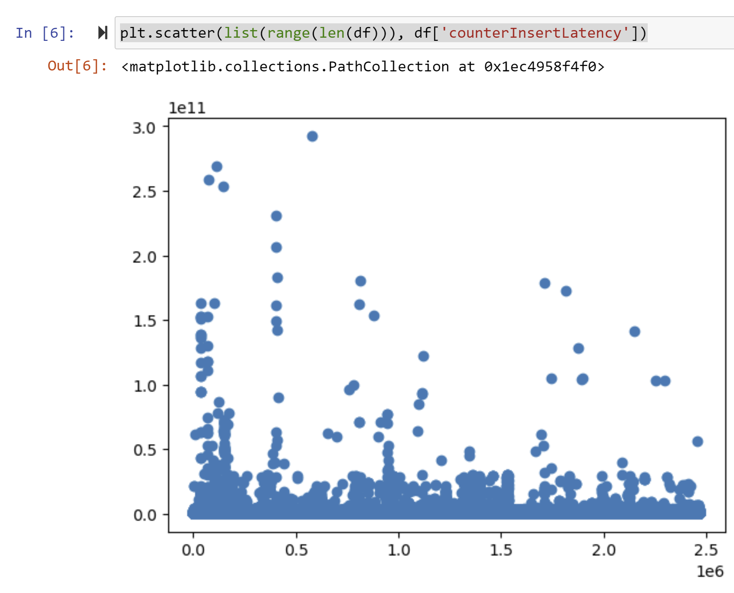

**Conclusion**

For the futures and their latencies, the order type (buying or selling) would affect the latency, and the Type of device used to conduct trades would also have an effect. This doesn’t mean that they are exactly correlated, but this variable can be a factor in affecting response and return rates. Another thing that affected the latency was the time of day, and it seems as all the other variables when performing a correlation test does not correspond or relate somehow to the security latencies. One thing that was hard to determine was the actual correlation, since numerical data points such as ID addresses might not exactly be correlated numerically, but some might be higher than others, which can be a factor in latency, and you can only see when plotting the graphs which is something that I took onto the next point. Taking a look at the hypothesis test, it seems like a lot of the variables do affect the latency, but there isn’t a specific correlation between these values.

**Variables that affect the response and return latencies:**

Time of day, exchangeIp, direction, combOffsetFlag, instrumentId, accountRef, counterIp.

It seems that for all the latencies in securities, although much of the data provided did not correlate with lower latencies in the 4 categories, many of the variables did affect the latencies of the trade when performing a hypothesis test between the values. Direction, IP addresses and branchIDs were the most significant in the change of latency. One other thing that was very significant was also the volume of trades. Things that did not affect latencies were price and quantity, and the total value of a security and market orders. Another thing that affected the latency was certain branchIDs, that seemed to have lower latencies compared to other branches. The clientIP values also had an effect as some IP addresses caused lower latency and others were higher.

**Suggestion:** The company might want to install more servers that would help and find out which instrument they trade with is the fastest to lower the latencies of trades. This would also lessen stress of the servers at certain times of day when the volume is greater.

**Variables that affect the 4 Latencies:**

Direction, BranchID, OrderRef, ClientIp*, Volume of trades during the day

Only 4 of the 8 ClientIPs had p-values that showed it was correlated with the trading latencies, which the other 4 ClientIPs didn’t affect latencies, and was proven with a lower median than others.

**Suggestion**: I believe one fix that the company can make is maybe add more servers to lessen the load of their other servers, thus decreasing the latency of trades during certain times or dates. This might also help decrease latencies from the clientIP and branchIDs as these servers might be closer to the clients, offering faster speeds.

**Errors and Reflection:**

One thing that I might change during the next experiment is to find the occurrences of certain values in the explanatory variable, because if there are only a few entries that come from that one data value, it would not be the most optimal to estimate if the latency has an effect or is correlated with it.